Physics 30 Unit D Assignment
Name: ___________

/60

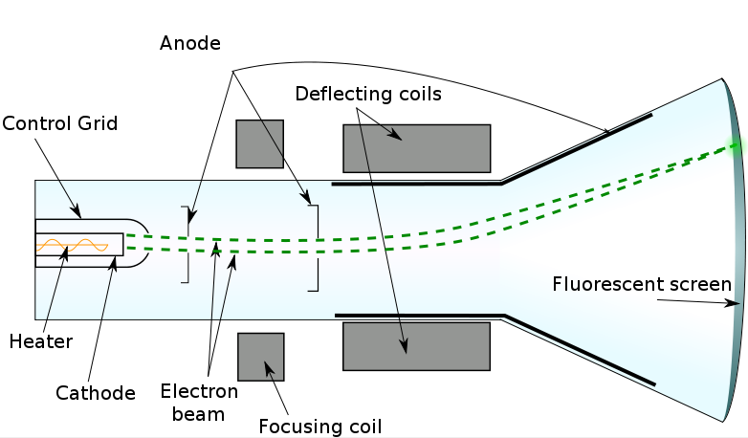
1. The diagram above shows a cathode ray tube or Crook’s Tube.

a) Give a brief description of how a CRT works. (2 marks)

b) Give a brief description of the importance of this device to modern physics. Include in your response specific experimental uses. (2 marks)

2. A group of physics students have been given a sample of unidentified charged particles. They are not given any hints about the particles, except that they appear in the fourth row of the periodic table (listed below). To determine the identity of the particle, they set-up an apparatus similar to J.J. Thomson’s charge to mass ratio experiment. Their apparatus has the following settings:
Velocity of particles: 4.5 x 10⁶ m/s
Magnetic Field Strength: 5.7 x 10⁻¹ T

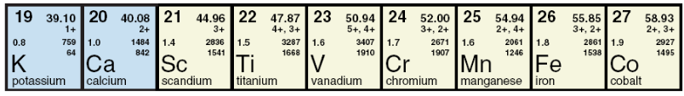
The students find the radius of curvature of the particles to be 98.057397 cm. From this information, determine the identity of the unidentified charged particle. (Hint: to find the mass of a single atom of any element, take the element’s molar mass and divide by Avagadro’s Number, N_{A} = 6.022 x 10²³) (Extra Hint: molar masses are given in g/mol) (Extra Extra Hint: Mr. Putnam likes to play golf!) (3 marks)

3. Ernest Rutherford had such success with his gold foil experiment that he was awarded the Nobel Prize in Chemistry in 1908. Briefly describe the gold foil experiment and explain why it was important to the development of the atomic model. (2 marks)

4. Maxwell delivered the final deathblow to the classical model of the atom. Briefly describe the classical model of the atom, what Maxwell said was wrong with this model, and the theory that “fixed” the problem that Maxwell had. (2 marks)

5. A helium-neon laser produces photons of wavelength 633 nm when an electron in a neon atom drops from an excited state to a lower state. Determine the energy difference between these two states, in eV. (1.96 eV) (3 marks)

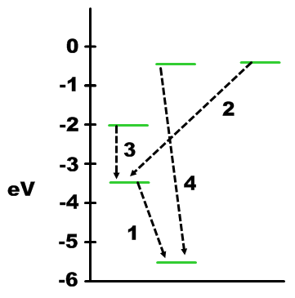
6. The diagram below shows some of the energy levels for the lithium atom. Transitions down between orbitals (emissions of photons) are numbered 1-4.

a) Explain how you could qualitatively order the photons emitted by each transition from smallest wavelength to largest wavelength. (2 marks)

b) Quantitatively determine the wavelength of the photon emitted by each transition and place them in order from lowest to highest. (5 marks)

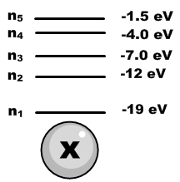
7. A high speed electron with 8.2 eV of kinetic energy strikes an electron in the second energy state of atom x to the right.

a) Determine the maximum jump the electron in orbit can jump to and the energy the original high speed electron leaves with. (electron can jump from 2nd to 4th orbital, high speed electron leaves with 0.20 eV of energy) (2 marks)

b) What is the wavelength of a photon emitted when an electron jumps down from the 5th to the 3rd quantum orbit? (226 nm) (3 marks)

c) To what part of the spectrum does this photon belong? _________ (1 mark)

Use the diagram below to answer the next question.

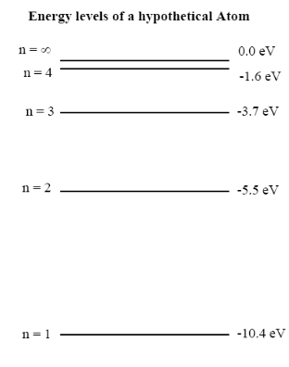
8. a) Why are the energy values in the diagram negative? (1 mark)

b) Why do the absolute of the energy values in the diagram decrease as the orbital number increases? (1 mark)

c) What is meant by n = ∞? (1 mark)

d) What is the ionization energy for an electron in the 2nd orbital of this atom? (1 mark)

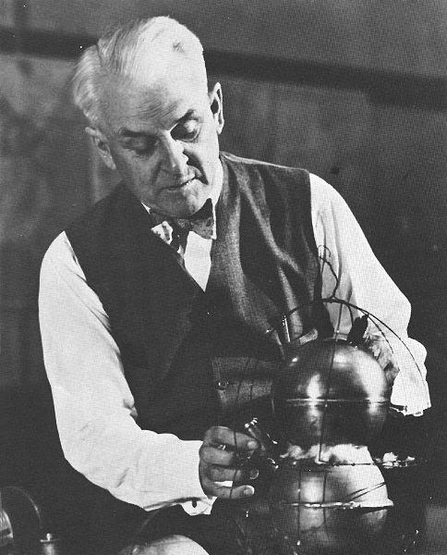
9. In Millikan’s oil drop experiment, an oil droplet is suspended between two charged parallel plates. The following information is collected:
Experimental Data

radius of oil drop = 4.2 x 10⁻⁶ m
density of oil = 7.8 x 10² g/m³
distance between plates = 2.0 cm
potential difference between plates = 99 V

Using the information given above and your knowledge of such experiments:

- Calculate the magnitude of the charge on the oil droplet. (3 marks) The following formulae may be useful:
    - Volume of a Sphere = (4/3) π r³ where r = radius
    - Density = mass/ volume

- Explain how Millikan could use the value of q to determine the elementary charge. (1 mark)

10. Compare and contrast the quantum model of the atom with Bohr’s model. (1 mark)

11. A list of energies present in each orbital of a hypothetical atom are below:

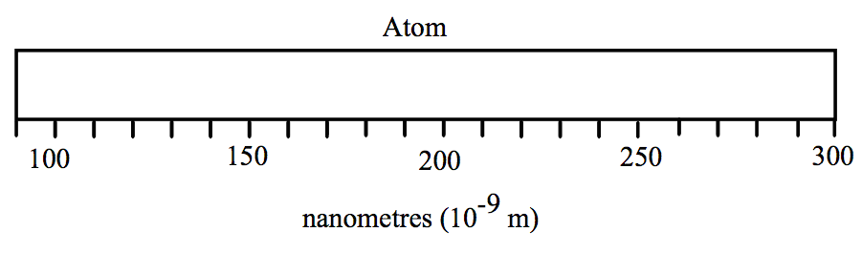
n₁ = -14 eV
n₂ = -5.5 eV
n₃ = -1.3 eV

Calculate each possible emission line and place it on the emission spectrum above. Show your calculations below. (3 marks)

12. The reaction below shows artificial transmutation of uranium-235. Fill in the boxes to complete the reaction. (1 mark)
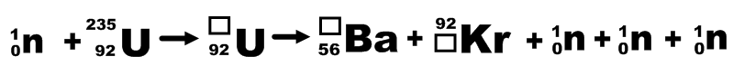

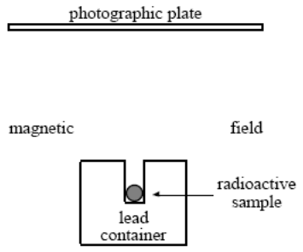
13. The diagram shows a radioactive sample in a lead container. The sample radiates through a magnetic field that is directed into the page perpendicular to the plane of the page.

On the diagram, show the deflection of the radiation of three major decay products due to the magnetic field, identify them, and show their electric charge. (2 marks)


14. Chalk River Laboratories in Ontario provides about two-thirds of the world’s medical radioactive isotopes. The isotopes are used to treat diseases and for diagnostic purposes in the body. A common isotope produced at Chalk River is Molybdenum-99. A decay chart of this radioisotope is shown below:

Activity (Bq) | Time (days)
2000 | 0.0
428.6 | 6.0
91.86 | 12
19.69 | 18
4.219 | 24

a) Construct a graph of activity vs. time for Mo-99. (1 mark)

b) Using your graph or an appropriate regression method, estimate the half-life of Mo-99. (2.7 days) (1 mark)

c) Using your answer from part b, determine the percentage of Mo-99 left in a patient’s body after one month (30 days). (1 mark) (~ 4.5 x 10⁻² %)

15. Write decay reactions for each of the following transmuations. Show all sub-atomic particles produced: (1 mark each)

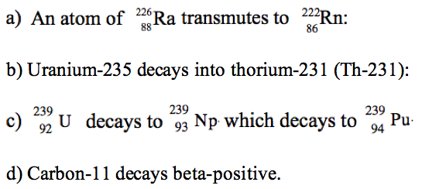
______________________________

______________________________

______________________________

______________________________

16. The diagram shows a type of radioactive decay, where the black spheres represent protons and the white spheres represent neutrons.



Name and give the notation for the type of particle that is emitted during this reaction. (1 mark)

17. A student was given the following reactions to complete:
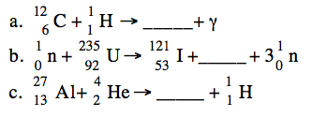
In the blank spaces, place the notation that will complete the reaction. (1 mark each)

18. a) Write the process for the alpha decay producing lead-208. (1 mark)

b) Estimate the kinetic energy of the alpha particle. (8.98 MeV) (2 marks)

19. a) Write a complete decay process for the transmutation of phosphorus-30 into silicon-30. (1 mark)

b) Calculate the energy released in this decay. (4.243 MeV) (2 marks)

