Physics 30 – EMR Assignment

- Of radio waves, light or X-rays, which has the largest (3 marks)

- wavelength
- frequency
- velocity

- Suppose that an alien from outer space uses microwaves to see. Based on this assumption, would you expect the alien’s eyes to be larger or smaller than our own? Why? (2 marks)

- Find the range of wavelengths (in a vacuum) for visible light in the frequency range between 4.0 x 10¹⁴ Hz (red light) and 7.9 x 10¹⁴ Hz (violet light). Express your answer in nanometers. (7.5 – 3.8 x 10² nm) (4 marks)

- In astronomy, distances are often expressed in light-years. One light-year is the distance traveled by light in one year. The distance to Alpha Centauri, the closest star to our sun which can be seen by the naked eye, is 4.3 light years. Express this distance in meters. (4.1 x 10¹⁶ m) (3 marks)

- a) Neil Armstrong was the first person to walk on the moon. The distance between the earth and the moon is 3.85 x 10⁸ m. Find the time it took his voice to reach earth using radio waves. (1.28s) (3 marks)

b) Determine the communication time for the first person who will walk on Mars, which is 5.6 x 10¹⁰ m from Earth at the closet approach. (1.9x10²s) (3 marks)

- Television sets sometimes use “rabbit ears” to improve reception. The length of each rod can be adjusted to be one-quarter of a wavelength of an electromagnetic wave whose frequency is 60.0 MHz. How long is each rod? (1.25 m) (3 marks)

- The human eye is most sensitive to light having a frequency of about 5.5 x 10¹⁴ Hz, which is in the yellow-green region of the EM spectrum. How many wavelengths of this light can fit across the length of your thumb, a distance of 2.0 cm? (3.7 x 10⁴ wavelengths) (4 marks)

- Two astronauts are 1.5 m apart in a spaceship. One speaks to the other. The conversation is transmitted back to earth via radio waves. The time it takes for sound waves to travel at 343 m/s through the air between the astronauts equals the time it takes for the electromagnetic waves to travel to the earth. How far from the earth is the spaceship? (1.3 x 10⁶ m) (4 marks)

- A mirror faces a cliff, located some distance away. Mounted on the cliff is a second mirror, directly opposite the first and facing towards it. A gun is fired very close to the first mirror. The speed of sound is 343 m/s. How many times does the flash of the gunshot travel the round trip distance between the mirrors before the echo of the gunshot is heard? (8.75 x 10⁵ times) (3 marks)

- The drawings below show two arrows, A and B, that are located in front of a plane mirror. A person standing at point P is viewing the image of each arrow. Which image can be seen in its entirety? Determine your answers by drawing a ray diagram. (3mks)
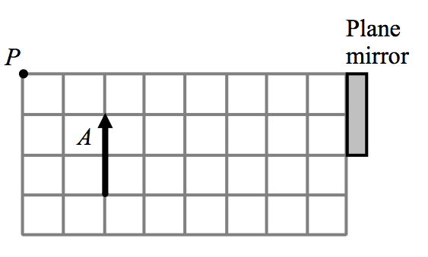
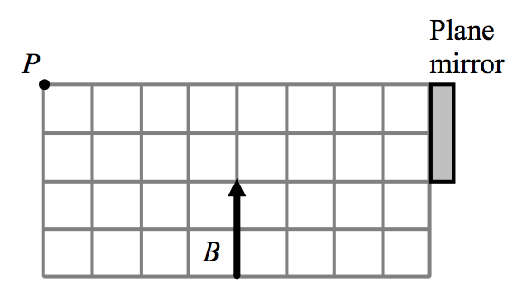


- On the +y-axis of the grid below, a laser is located at y = +3.0 cm. The coordinates of a target are x = +9.0 cm and y = +6.0 cm. The x-axis represents a mirror, reflective surface facing upwards. At what point on the x-axis should the laser be pointed to hit the target after reflection? Use the grid below to form your answer. (3mks)

- The drawing shows two plane mirrors that are spaced 50° apart. An incident light ray hits the bottom mirror, then reflects to the top mirror. Determine the angle θ between incident and reflected ray. (100°) (3mks)
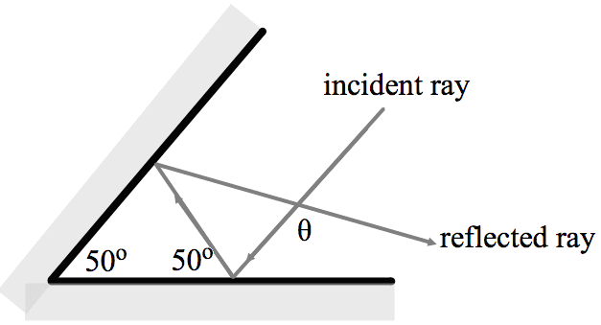

- A flat sheet of ice has a thickness of 2.0 cm and an index of refraction of 1.309. It is on top of a flat sheet of crystalline quartz that has a thickness of 1.1 cm. and an index of refraction of 1.544. Light strikes the ice perpendicularly and travels through it and then through the quartz. In the time it takes the light to travel through the two sheets, how far (in cm) would it have traveled through a vacuum? (4.3 cm) (5mks)

- The drawing shows a coin resting at the bottom of tank filled with an unknown liquid. A ray of light travels from the coin to the surface of the light and is refracted, entering an observers eye, but without leaving the surface of the liquid. Determine the speed of light in this liquid. (1.92 x 10⁸ m/s) (3mks)
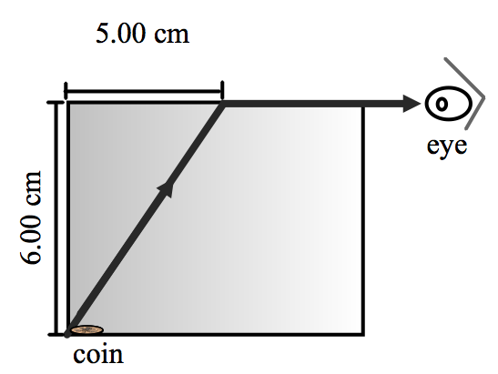

- A 2.0 cm high object is situated 15.0 cm in front of a concave mirror that has a radius of curvature of 10.0 cm.

Calculate a) the location and b) the height of the image. (7.5cm, -1.0cm) (4mks)

- Repeat the above problem for a concave mirror with a focal length of 20.0 cm, an object distance of 12.0 cm and a 2.0 cm high object. (-30.0cm, 5.0cm) (4mks)

- An object that is 25 cm in front of a convex mirror has an image located 17 cm behind the mirror. How far behind the mirror is the image located when the object is 19 cm in front of the mirror? (-14 cm) (3mks)

- An object is 18 cm in front of a diverging lens that has a focal length of -12 cm. How far in front of the lens should the object be placed so that the size of its image is reduced by a factor of 2.0? (36 cm) (3mks)

- The moon’s diameter is 3.48 x 10⁶ m, and its mean distance from the earth is 3.85 x 10⁸ m. The moon is being photographed by a camera whose lens has a focal length of 50.0 mm.
a) Find the diameter of the moon’s image on the film negative. (4.52 x 10⁻⁴ m) (3mks)

b) When the negative is projected onto a screen that is 15.0 m from the lens of the projector (f = 110.0 mm), what is the diameter of the moon’s image on the screen? (6.12 x 10⁻² m) (3mks)

- In a Young’s double-slit experiment, the angle that locates the second-order bright fringe is 2.0°. The slit separation is 3.8 x 10⁻⁵ m. What is the wavelength of the light used? (663 nm) (3mks)

- Violet light (λ = 410 nm) and red light (λ = 660 nm) lie at opposite ends of the visible spectrum.

a) For each colour of light, find the angle θ that locates the first antinode produced by a diffraction grating with 3300 lines/cm. This grating converts a mixture of all colours between violet and red into a rainbow-like dispersion between the two angles. (θ_{v}=7.78°, θ_{r}=12.6°) (4mks)

b) Repeat the calculations for the second antinodes (you do not have to show your work).
(θ_{v}=15.7°, θ_{r}=25.8°) (2mks)

c) Repeat the calculations for the third antinodes (you do not have to show your work).
(θ_{v}=23.9°, θ_{r}=40.8°) (2mks)

d) From your results, determine if there is any overlap between the “rainbows”, and, if so, specify where the overlap occurs. (1mk)

- In a Michelson setup for measuring the speed of light, mirrors are placed on Mt. San Antonio and Mt. Wilson in California, which are 35 km apart. Using the value of c for the speed of light through air, find the minimum speed of rotation (in rev/s) of the 8-sided mirror needed to see the reflected light beam. (536 rev/s) (3mks)

- What is the stopping voltage for an electron that has 8.5x10⁻¹⁹ J of kinetic energy? (5.3V) (3mks)

- Radiation with a frequency of 9.60x10¹⁵ Hz illuminates a photoelectric surface. If the work function of this surface is 4.50 eV, what is the stopping voltage required to reduce the current to zero? (35.3V/35.2V)(4mks)

- What is the wavelength of a 8.7 MeV photon? (1.5x10⁻¹³m/1.4x10⁻¹³m) (4mks)

- A photoelectric surface has a work function of 3.65 eV. What is the minimum frequency of light needed to cause electrons to be ejected from this surface? (8.81x10¹⁴Hz/8.82x10¹⁴Hz) (3mks)

- Calculate the momentum of a photon with a frequency of 9.99x10¹⁴ Hz. (2.21x10⁻²⁷kgm/s) (3mks)

- Calculate the momentum of an electron that was accelerated from rest through a potential difference of 3400V. (3.15x10⁻²³kgm/s) (6mks)

- If a photon with a frequency of 3.8x10¹⁷ Hz collides with an electron at rest and loses 40% of its energy, what is the speed of the electron after the collision? (3.7x10⁵m/s) (7mks)

- How many photons are emitted per second by a 5.0 W helium-neon laser that produces a wavelength of 750nm? (1.9x10¹⁹ photons/s) (4mks)

