Science 20: Final Examination Review

UNIT A - CHEMICAL CHANGES

1. What are the properties of solutions?
2. Define solute, solvent, saturated and unsaturated solutions.
3. What is the difference between electrolytes and non-electrolytes?
4. Describe how to prepare a solution of a certain concentration.
C = n/V C₁V₁ = C₂V₂
5. Be able to balance single replacement chemical equations.
6. Use of molar ratios to predict unknown quantities - stoichiometry.
7. What does the Activity Series show?
8. Understand the process of oxidation-reduction.
- Define cathode, anode, salt bridge, half-cell, electrodes, electrolyte solution.
10. What is corrosion? What are the methods that can be used to prevent it?
11. What is a galvanic cell? How do you build one? What does it produce?
12. What is an electrolytic cell? How does it work? What is it used for? Give examples of processes using electrolysis.
13. What are hydrocarbons?
14. How do you name alkanes, alkenes and alkynes? What are their general formulas?
15. Be able to name organic compounds and draw their structural formulas.
16. What is a polymer? Give examples of natural and man-made polymers. How can you produce polymers?
17. Be able to write reactions for each of the hydrocarbon reactions in the data booklet.

Science 20 Unit A Review Test Questions:

1. Water is a good medium for chemical change because it

A. helps the solute mix uniformly
B. breaks the bonds of the solute(s)
C. allows new bonds to form, allowing for new substances
D. all of the above

2. Cobalt(II) nitrate is dissolved in water. The cobalt(II) nitrate is considered to be the

A. product
B. solution
C. solvent
D. solute

3. Water is an effective solvent for ionic compounds because

A. each water molecule has a negative end and a positive end
B. water and ionic compounds have the same charge
C. ionic compounds have a negative charge
D. water has a negative charge

4 Which substance is a non-electrolyte?

A. calcium carbonate
B. aqueous ethanol
C. hydrochloric acid
D. sodium sulfate

5. Match each description with the appropriate term listed. Place your answer in the blank space given.

i. solute ii. exothermic change iii. non-electrolyte iv.solvent
v. solution vi. chemical change vii. dissociation
viii. endothermic change ix. aqueous solution x. electrolyte

___ a. a substance in a solution that breaks down the bonds of a solute; a substance that
does the dissolving and is in greater proportion in the mixture
___ b. a solute that forms a solution that conducts electricity
___ c. a change in which one or more new substances with different properties are
formed
___ d. a homogeneous mixture of dissolved substances that contains a solute and a
solvent
___ e. a chemical change in which energy is absorbed from the surroundings
___ f. a solution in which water is the solvent
___ g. the separation of an ionic compound into individual ions in a solution
___ h. a chemical change in which energy, usually in the form of heat, is released into
the surroundings
___ i. a substance in a solution whose bonds are broken by a solvent; a substance that
dissolves
___ j. a solute in a solution that does not conduct electricity

6. Decide whether each statement is true (T) or false (F). Place your answer in the blank space given.

___ a. Some molecular compounds dissolve in water.
___ b. It is important to rinse the probes of a conductivity meter when testing more than
one solution.
___ c. Aqueous acetone is extremely flammable.
___ d. As a general rule, solutions with ionic compounds are electrolytes and solutions
with molecular compounds are non-electrolytes.
7. A concentrated solution is one that has

A. no solvent
B. more solute than solvent
C. a high ratio of solute to solvent
D. a low ratio of solute to solvent

8. Which is an advantage of selling plant fertilizer as a powder rather than as a liquid?

A. Transportation costs are reduced.
B. The powder must be stored in a childproof container.
C. The powder may be a health hazard if proper procedures are not followed during mixing.
D. The gardener has to be able to read directions carefully and mix the proper amount of
solvent and solute.

9. Which household product is a dilute solution?

A. vinegar
B. orange juice
C. oven cleaner
D. toilet bowl cleaner

10. A solution is diluted by removing half the amount and then adding solvent to return the solution to its original volume. This process is repeated two more times. What fraction of the original concentration is the concentration of the final solution after the third dilution?

A. 1/8
B. 1/4
C. 1/2
D. 3/4

11. Which is not a reason why a solution with a greater concentration reacts faster than a solution that is more dilute?

A. A chemical reaction is a result of collisions between particles.
B. A dilute solution has more particles of solute available for collisions than a concentrated
solution.
C. A concentrated solution has more particles of solute available for collisions than a dilute
solution.
D. The probability of collisions increases as the number of solute particles within a system
increases.

12. Decide whether each statement is true (T) or false (F). Place your answer in the blank space given.

___ a. The carbonated water in fountain pop is the solute.
___ b. A theory stating that chemical reactions involve the collision and rearrangement
of particles is known as qualitative reaction theory.
___ c. A solution that contains a low ratio of solute to solvent is a dilute solution.
___ d. The ratio of quantity of solvent to quantity of solution is the concentration of a
solution.

13. For which calculation is the following formula used?

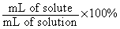

A. molar concentration
B. parts per million
C. percent by volume
D. percent of solvent

14. A bottle of insect repellent states that the percent by volume concentration of DEET is 14%. What volume of DEET is in a 500-mL container?

A. 35 mL
B. 70 mL
C. 140 mL
D. 500 mL

15. Which concentration measurement is used for very dilute solutions?

A. percent by volume
B. parts per million
C. moles per litre
D. milligrams per litre
16. A gardener requires 2000 mL of insecticidal soap solution with a concentration of 7.0% by volume concentration. The volume of insecticidal soap needed is

A. 3.5 x 10¹ mL
B. 1.4 x 10² mL
C. 2.0 x 10³ mL
D. 1.4 x 10⁴ mL

17. A student is given 0.325 g of CaCl₂(s) and is instructed to make 25.0 mL of
0.100-mol/L CaCl₂(aq) using all of the solid. The following materials are provided:

1. stirring rod 2. Bunsen burner 3. graduated cylinder
4. thermometer 5. 50-mL beaker 6. burette
7. hot plate 8. ring stand 9. CaCl₂(s)
10. distilled water 11. crucible

Which list contains only the materials the student will need to produce the solution?

A. 1, 3, 5, 6, 9
B. 3, 4, 5, 9, 10
C. 1, 3, 5, 9, 10
D. 1, 5, 6, 9, 10

18. A 3.00-mol/L sodium phosphate solution, NaPO₄(aq), is used to make 250 mL of 0.50-mol/L sodium phosphate solution. It is determined that 42 mL of the concentrated solution is needed for the dilution. Steps that may be used to make the solution are as follows:

1. Insert a stopper into the volumetric flask.
2. Add distilled water to the volumetric flask until the 250-mL level is reached.
3. Add 42 mL of the sodium phosphate solution to 500 mL of distilled water.
4. Transfer 42 mL of the 3.00-mol/L solution into a 250-mL volumetric flask.
5. Heat the solid sodium phosphate to change it into a liquid.
6. Invert the volumetric flask to mix the contents.

Which steps, in the proper order, are required to produce the 0.50-mol/L sodium phosphate solution?

A. 3, 5, 2, 6
B. 4, 2, 1, 6
C. 2, 3, 4, 6, 5
D. 5, 2, 4, 1, 6

19. The number of grams in three moles of solid ammonium chloride, NH₄Cl(s), is

A. 50.47 g
B. 53.50 g
C. 102.96 g
D. 160.50 g

20. A student dissolves 45.2 g of Mg(OH)₂(s) in enough water to make 1.00 L of solution.
The concentration of this solution is

A. 4.52 mol/L
B. 1.00 mol/L
C. 0.775 mol/L
D. 0.109 mol/L

21. A teacher wants to make 200 mL of a 0.600-mol/L solution of KOH(aq). What volume of
a 2.00-mol/L stock solution is required for this dilution?

A. 60.0 mL
B. 240 mL
C. 667 mL
D. 1.67 x10⁴ mL

22. Match each description with the appropriate term listed. Place your answer in the blank space given.

i. standard solution ii. mole iii. acid iv. molar concentration
v. molar mass vi. conversion factor

___ a. a specific amount of a substance that consists of 6.022 1023 particles
___ b. a fraction used to convert one set of units into another
___ c. the amount of solute, in moles, per litre of solution
___ d. a solution having a precisely known concentration
___ e. a substance that produces hydrogen ions when dissolved in water to form a
conducting aqueous solution
___ f. the mass of one mole of a substance

23. Decide whether each statement is true (T) or false (F). Place your answer in the blank space given.

___ a. Percent by volume is commonly used for solids dissolved in liquids.
___ b. 70 mL of ethanol combined with 50 mL of water will give a combined volume
that is less than 120 mL.
___ c. The term parts per million means “one part solvent for every million parts of
solute.”
___ d. Molar mass of a compound is the sum of the molar masses of the individual
elements.

24. A 400-g sample of water contains 4.50 x 10^{–5} g of arsenic.

Calculate the concentration of arsenic in the water sample in parts per million. Show your work.

25. A technician measures 1.75 L of a standard solution of hydrochloric acid, HCl(aq), with a concentration of 9.00 mol/L. Determine the amount of water that must be added to create a solution with a concentration of 2.50 mol/L.

26. What happens when a strip of zinc is placed in a silver nitrate solution?

A. Hydrogen bubbles form on the strip of zinc, and zinc ions go into the solution.
B. Zinc ions go into the solution, and silver forms on the strip of zinc.
C. A chemical reaction involving zinc does not take place.
D. Zinc ions go into the solution, and oxygen forms.

27. What happens when a strip of plastic is placed in a silver nitrate solution?

A. A chemical change involving plastic is not observed.
B. Hydrogen bubbles form on the strip of plastic.
C. The plastic quickly disintegrates.
D. Silver forms on the strip of plastic.

28. Based on the equation 4 Ag(s) + 2 H₂S(g) + O₂(g) 2 Ag₂S(s) + 2 H₂O(l), what is the mole ratio of H₂S(g) to Ag₂S(s)?

A. 2/1
B. 2/2
C. 2/4
D. 4/2

30. Hydrogen sulfide can be used in aqueous solutions to separate out metal ions. On the other hand, hydrogen sulfide in the air causes considerable damage to silver objects. When a silver goblet tarnished in the presence of hydrogen sulfide (and oxygen), 1.20 mol of silver sulfide formed. What amount of silver was consumed?

____ H₂S (aq) + ___Ag (s) ___ H₂ (g) + ___ Ag₂S (aq)

A. 4.80 mol
B. 2.40 mol
C. 1.20 mol
D. 0.600 mol

31. While investigating mole ratios, a group of students collected data for the chemical reaction 2 NaOH(aq) + CaCl₂(aq) 2 NaCl(aq) + Ca(OH)₂(s). The students wondered what would happen if an excess of NaOH was used. Their teacher approved a procedure in which solutions containing 3.00 g of NaOH and 2.10 g of CaCl₂ were combined. Based on the quantities of these reactants, what amount of Ca(OH)₂(s) is produced?

A. 0.0189 mol
B. 0.0375 mol
C. 0.0500 mol
D. 0.1000 mol

32. In producing pure iron metal from its ore, iron (III) oxide and carbon (coke) must react according to the following balanced chemical equation:

Fe₂O₃(s) + 3 C(s) 2 Fe(s) + 3 CO(g)

Suppose 5.89 x 10³ mol of iron ore are consumed. How many moles of pure iron metal are produced?

A. 1.47 x 10³ mol
B. 2.95 x 10³ mol
C. 5.89 x 10³ mol
D. 1.18 x 10⁴ mol

33. One essential step in the manufacture of many plant fertilizers is the production of nitrogen monoxide gas, NO(g). This step is represented by the following balanced equation:

4 NH₃(g) + 5 O₂(g) 4 NO(g) + 6 H₂O(l)

Determine the amount of oxygen needed to produce 1.2 x 10⁴ mol mol of nitrogen monoxide gas.

34. Which is an example of oxidation?

A. K⁺(aq) + e– K(s)
B. Au³⁺(aq) + 3e– Au(s)
C. Fe²⁺(aq) + 2e– Fe(s)
D. Li(s) Li⁺(aq) + e–

35. Which is an example of reduction?

A. Ca(s) Ca²⁺(aq) + 2e–
B. Fe³⁺(aq) + e– Fe²⁺(aq)
C. H₂(g) 2 H⁺(aq) + 2e–
D. Zn(s) Zn²⁺(aq) + 2e–

36. Decide whether each statement is true (T) or false (F). Place your answer in the blank space given.

a. A substance that oxidizes gains electrons.
b. When copper is purified from copper sulfide, copper is reduced.
c. When tarnished silver becomes shiny, the silver is reduced.
d. As an iron object rusts, the iron undergoes reduction.

37. When zinc metal is placed into a solution of silver nitrate, silver metal and zinc nitrate are produced according to this reaction:
Zn(s) + 2 AgNO₃(aq) 2 Ag(s) + Zn(NO₃)₂(aq)

a. What chemical atom or ion in the reaction is oxidized? Give a reason for your choice.

b. What chemical atom or ion in the reaction is reduced? Give a reason for your choice.

38. Rewrite each reaction so it is balanced.

a. Al(s) + I₂(s) AlI₃(s)

b. Fe(s) + O₂(g) Fe₂O₃(s)

c. Zn(s) + AuCl₃(aq) Au(s) + ZnCl₂(aq)

39. Tin does not react with iron (II) oxide, but it does reduce lead (II) oxide to lead. What is the correct arrangement of the metals in order of decreasing reactivity?

A. tin, lead, iron
B. iron, tin, lead
C. lead, iron, tin
D. tin, iron, lead

40. A student listed the following possible reactants in redox reactions:

I. iron and copper(II) sulfate solution
II. silver and calcium nitrate solution
III. zinc and lead(II) nitrate solution
IV. copper and lead(II) nitrate solution
V. magnesium and zinc nitrate solution

Which combination will spontaneously react in a redox reaction?

A. I and II
B. I, III, and IV
C. I, III, and V
D. V only

41. Which is least reactive with aqueous solutions of metal ions?

A. tin
B. zinc
C. gold
D. calcium

42. A block of magnesium attached to an iron pipeline running through moist soil may prevent the pipeline from oxidizing and corroding. Magnesium is a very reactive metal. When attached to the pipeline, the magnesium itself will corrode and keep the pipeline a cathode. Based on this form of protection, which of these metals can also protect an iron pipeline from corrosion?

A. zinc
B. lead
C. copper
D. silver

Use the following diagram to answer the next four questions.

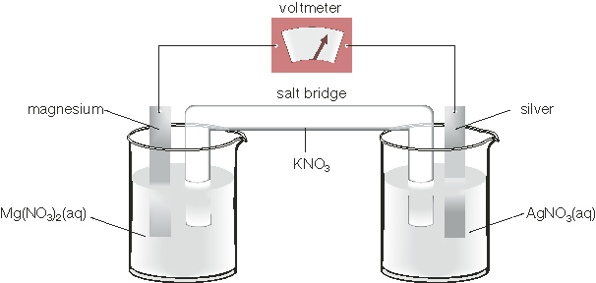

43. The reduction-half reaction for the cell is

A. Ag⁺(aq) + e– Ag(s)
B. Ag(s) Ag⁺(aq) + e–
C. Mg(s) Mg²⁺(aq) + 2e–
D. Mg²⁺(aq) + 2e– Mg(s)

44. The oxidation half-reaction for the cell is

A. Ag⁺(aq) + e– Ag(s)
B. Ag(s) Ag⁺(aq) + e–
C. Mg(s) Mg²⁺(aq) + 2e–
D. Mg²⁺(aq) + 2e– Mg(s)

45. The oxidation half-reaction occurs at

A. the anode
B. the cathode
C. the anode and the cathode
D. neither the anode nor the cathode

46. The electrode mass will diminish at

A. the anode
B. the cathode
C. the anode and the cathode
D. neither the anode nor the cathode

47. Describe the role of a salt bridge in a voltaic cell.

Use the following information to answer the next 3 questions.

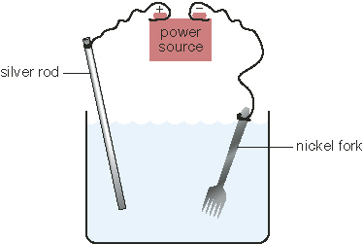

48. Which statement identifies the cathode and correctly describes the electron flow?

A. Electrons flow from the nickel fork to the silver rod, which is the cathode.
B. Electrons flow from the nickel fork, which is the cathode, to the silver rod.
C. Electrons flow from the silver rod to the nickel fork, which is the cathode.
D. Electrons flow from the silver rod, which is the cathode, to the nickel fork.

49. Which solution allows the electrolytic cell to perform the silver plating?

A. nickel nitrate
B. silver nitrate
C. sodium chloride
D. gold(I) chloride

50. How is the operation of the electrolytic cell explained as a redox reaction?

A. Silver is oxidized at the fork and reduced at the silver rod.
B. Silver is reduced at the fork and oxidized at the silver rod.
C. Nickel is reduced at the fork, and silver is oxidized at the silver rod.
D. Nickel is oxidized at the fork, and silver is reduced at the silver rod.

Use the diagram to answer the next question.

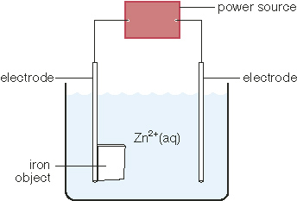.

51. a. Identify the type of cell depicted in the diagram.

b. Why is an external power source needed for the chemical change to occur in the cell?

52. What is the chemical name for the liquid fuel component C₁₀H₂₂(l)?

A. butane
B. decane
C. nonane
D. methane

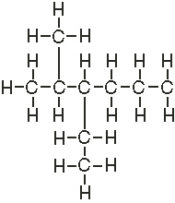
53. What is the name of the hydrocarbon on the right?

A. 3-ethyl-2-methylhexane
B. 2-methyl-3-ethylhexane
C. 5-methyl-4-ethylhexane
D. 4-ethyl-5-methylhexane

54. Draw the complete structural diagram of the hydrocarbon 3,3-diethylheptane.

55. The following are steps in the formation of a double-bond hydrocarbon molecule from a single-bond hydrocarbon molecule:

1. The closest thing to bond with is the electron from the other carbon atom.
2. Two hydrogen atoms leave the carbon chain.
3. Twisting occurs to accommodate the double bonds.
4. Both carbons bond with each other to form a double bond.
5. Both carbons have an unbonded electron.

The correct order of the steps in the formation of a double-bond hydrocarbon molecule from a single-bond hydrogen molecule is

A. 2, 4, 1, 3, 5
B. 1, 2, 3, 4, 5
C. 2, 5, 1, 4, 3
D. 5, 1, 4, 2, 3

56. Why do saturated fats tend to be solid at room temperature, whereas unsaturated fats tend to be liquid?

A. The chains of fatty acid molecules in saturated fats are straight and require more energy to break the bonds between adjacent molecules.
B. The chains of fatty acid molecules in saturated fats are bent and require less energy to break the bonds between adjacent molecules.
C. The chains of fatty acid molecules in unsaturated fats are straight and require less energy to break the bonds between adjacent molecules.
D. The chains of fatty acid molecules in unsaturated fats are bent and require more energy to break the bonds between adjacent molecules.

57. The ending -yne is used for hydrocarbons with

A. only single bonds
B. at least one double bond
C. at least one triple bond
D. only double and triple bonds

Use the following diagram to answer the next three questions.
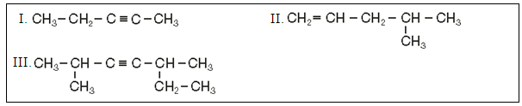
60. Compound I is

A. 3-pentene
B. 2-pentene
C. pent-3-yne
D. pent-2-yne

61. Compound II is

A. 2-methyl-4-pentene
B. 2-methyl pent-4-ene
C. 4-methyl pent-1-ene
D. 4-methyl-1-pentene

62. Compound III is

A. 2,5-dimethyl hex-3-yne
B. 2,5-dimethyl hept-3-yne
C. 2-ethyl-5-methyl hex-3-yne
D. 2-ethyl-5-methyl hept-3-yne
63. In fractional distillation, the number of carbons in the different components produced

A. stay the same throughout the distillation tower
B. increase as the vapours move up the distillation tower
C. decrease as the vapours move up the distillation tower
D. increase then decrease as the vapours move up the distillation tower

64. The purpose of cracking in the production of ethene is to

A. convert large molecules into small molecules
B. convert small molecules into large molecules
C. evaporate the lightest molecules from the mixture
D. condense light molecules into large molecules

Use the following information to answer the next question.
The following equation represents the cracking of a 14-carbon hydrocarbon into smaller hydrocarbons:
C₁₄H₃₀(g) → C₃H₈(g) + C₅H₁₀(g) + C₆H₁₂(g)

65. The reactant hydrocarbon is

A. an alkane
B. an alkene
C. an alkyne
D. none of the above

66. Which product is an alkane?

A. C₃H₈(g)
B. C₅H₁₀(g)
C. C₆H₁₂(g)
D. C₈H₁₆(g)

67. Match each description with the appropriate term listed. Place your answer in the blank space given.

i. petroleum ii. cracking iii. fraction
iv. refining v. naptha vi. fractional distillation

___ a. a reaction in which hydrocarbons are broken down into smaller molecules by
means of heat or catalysts
___ b. an industrial process that separates, purifies, and alters raw materials
___ c. liquid hydrocarbons formed over millions of years from the remains of ancient
microscopic marine organisms
___ d. a group of compounds found in petroleum with similar properties and uses
___ e. a mixture of hydrocarbons containing between five and ten carbon atoms
___ f. a process used for the separation of a liquid mixture by vaporizing it and
collecting the different components of the mixture as they cool down and condense at their appropriate boiling points

UNIT B - CHANGES IN MOTION

1. What is the difference between a vector and scalar quantity? Give examples.
2. What is the difference between distance and displacement? Speed and velocity?
3. Define acceleration.
4. Be able to calculate motion problems using velocity and/or acceleration data.
5. What are Newton's Three Laws?
6. What is the relationship between mass, force and weight?
7. Be able to use the acceleration due to gravity, -9.81 m/s².
8. How are force and acceleration related?
9. Explain impulse and momentum? Give examples.
10. Law of Conservation of Momentum?
11. Unit Conversions
12. Significant Digits
13. Be able to make and interpret graphs of uniform motion and accelerated motion.

Science 20 Unit B Review Test Questions:

1. a) Define:

Scalar: ___________________________________________________________

Vector: ___________________________________________________________

b) In the spaces below, put “V” for Vector and “S” for scalar:

_________ Displacement
_________ Speed
_________ Velocity
_________ Acceleration
_________ Distance
_________ Force
_________ Momentum
_________ Energy

c) When reading a question with scalars and vectors in it, how do you tell which is which?

2. Convert the following.

2.5 km = __________ m

6.9 kg = __________ g

8.3 cm = __________ m

5.0g = __________ kg

8.9 hours = __________ s

246 mm = __________ km

7200 s = __________ h

5.32 x 10⁵mm= __________ m

3. Convert:

a) 260 km/h = ___________ m/s b) 0.345 km/h = __________ m/s

4. Seth Cohen walks 275m east to the comic store, then turns around and walks 425m west to the 7-11.

- What is the DISTANCE traveled by Seth Cohen?

- What is the DISPLACEMENT traveled by Seth Cohen?

5. A caterpillar travels across Summer’s 5.00m porch in 1.5 minutes. What is the average velocity of the caterpillar in m/s?

6. Marissa and Summer are at the bottom of a canyon facing the canyon wall closest to them. They are 267m from the wall and the speed of sound is 340m/s at that location. How long after they shout will they hear their echo?

7. Seth is traveling on a straight stretch of highway, setting his cruise control at a constant velocity of 140 km/h. How far will he travel in 15 minutes?

8. From the position vs. time graph to the right, determine
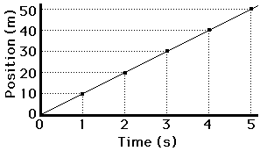
- The velocity of the object.

- The distance traveled between 0 and 5 seconds.

9. What is the acceleration of a racing car if its speed is increased uniformly from 44 m/s to 66 m/s over an 11 s period?

10. Find the acceleration of a racing car if its speed is decreased uniformly from 66 m/s to 44 m/s over an 11 s period.


11. Hercules shoots an arrow straight up with an initial speed of 98 m/s. Nine seconds later its velocity is only 9.8 m/s. At what rate is the arrow slowed down by gravity?

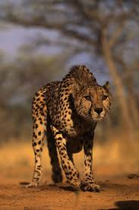
12. A cheetah is uniformly accelerating at 1.2 m/s² for 12 s. If the original speed of the cheetah is 18 m/s, find its final speed.

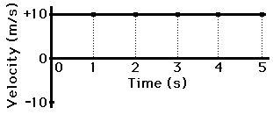
13. Find the displacement after 5 seconds for the object shown in the graph to the right.

14. Use the graph above to answer each question.

- During which time interval(s) is the object undergoing uniform motion?

- During which time interval(s) is the object undergoing accelerated motion?

- Calculate the acceleration between t=5 and t=6.

- Calculate the total displacement from t=0 to t=10.

15. An in-line skater is moving at a speed of 4.00 m/s when she hits a downhill. If the hill accelerates her at a constant rate of 0.40 m/s² and it takes her 5.00 s to get down the hill,

- How long is the hill?

- How fast is she going once she gets to bottom?

16. A car traveling at 80.0 km/h decelerates at a constant 1.5 m/s². Calculate:

- The distance it goes before it stops.

- The time it takes the car to stop.

17. A spaceship far away from any star or planet accelerates uniformly from 65.0 m/s to 162 m/s in 10.0 s. How far does it move in that time?

18. A man falls 1.00 m to the floor.

- How long does the fall take?

- How fast was he going when he hits the floor?

19. A student drops a rock from a bridge of water 12.0 m below. With what speed does the water strike the water?

20. A stone is dropped from the top of a cliff. If it takes 5.50 seconds to hit the ground, how high is the cliff?

21. If the force of 2000 N acts on a car with a mass of 950 kg, what will be the car’s acceleration?

22. If it takes 900 N of force to accelerate a car at a rate of 2.5 m/s², what is the mass of the car?

23. A 1250 kg dragster accelerates from 0 to 100 km/h in 2.1 seconds. What is the force required?

24. What is the weight of an 70.0 kg astronaut:

- on earth?

- on the moon (g=1.70 m/s²)

- on Venus (g=8.70 m/s²)

25. What is the momentum of a 3000-kg rhino running at a velocity of 15 m/s?

26. If a shark’s momentum is 500 kg•m/s, and its velocity is 5.50 m/s, then what is its mass?

27. If a bat’s momentum is 800 kg•m/s, and its mass is 0.450 kg, then what is its speed?

28. A dump truck (m = 8000 kg) broadsides a parked Honda Civic (m = 900 kg). The momentum before the crash is equal to the momentum after the crash. If the truck was traveling 90 km/h west:

- what was the speed of the wreckage after the crash if the velocity of the car after collision was 10 km/h west? Assume the cars hit and bounced?

- what was the speed of the wreckage after the crash if the cars hit and stuck.

30. A 50.0 kg bomb starting at rest explodes, with one part (m = 20 kg) flying left at 14 m/s. The rest of the mass is in the second part of the bomb, which flies right. What is the speed of the second part of the bomb?

UNIT C - OUR CHANGING EARTH

- How is geological time measured? What are eras, periods and epochs? What are the names of the four eras?
- Describe the Earth's early atmosphere and how it evolved.
- What is the Principle of Superposition?
- Theory of Plate Tectonics: What is it? Who first proposed it? Give evidence to support it?
Convection model of plate movement?
- Describe the geological phenomena that occurs at the plate boundaries: convergence, divergence and lateral movement.
- Describe the concept of "half-life". Calculate the age of a rock sample using half-lives of radioactive elements.
- The Rock Cycle - 3 main types of rocks, how they form and what processes convert them into other types of rocks?
- What are earthquake waves called. Name the types and their characteristics.
- Define seismology, seismograph, seismometer, epicentre, focus.
- How are earthquakes measured; Richter scale - logrithmetic scale - what does this mean? Intensity scale?
- Predicting earthquake movement, describe some of the technologies currently being used.
- What does paleontology mean? What are some types of fossils? In what type of rock would you expect to find fossils? What are index fossils?
- What can we learn from studying fossils? Can you interpret a stratigraphic column?
- Glaciation: types of glaciers. how they form. effects of glaciers. Theories accounting for the ice ages.
- What are some concerns about current and future global climate changes?

Science 20 Unit C Review Test Questions:

1. Which of the following describes why it is difficult to investigate Earth’s past?

- Because the changes that have occurred have been so small
- Because the changes that have occurred have been so large
- Because the changes have taken a long time to occur
- Because the changes have taken such a short time to occur

2. What is the main way that we investigate the changes that have occurred to life forms on the
Earth?

- Analyzing seismic data
- Analyzing volcanic data
- Analyzing fossils and strata information
- Analyzing fossils and comparing them to current organisms

3. The first theory to explain geological processes was known as

- Catastrophism
- Uniformitarianism
- Planetarium
- Terestrialism

4. Our current theory of geological processes states that

  - The geological processes in action today have always fundamentally operated in the same way throughout Earth’s history
  - The geological processes in action today have never operated in the same way throughout Earth’s history
  - The geological processes seen today have been a result of violent catastrophes
  - The geological processes seen today have been a result of nonviolent catastrophes

Use the following diagram to answer the next three questions
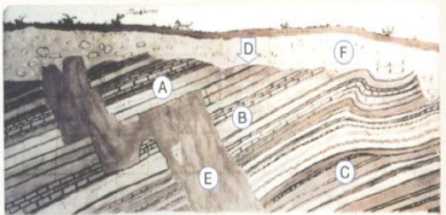

5. Which of the following letter indicates the youngest formation?

- A
- C
- E
- F

6. What is the proper term for F and what was likely to cause it?

  - Unconformity caused by erosion
  - Unconformity caused by volcanic activity
  - Nonconformed caused by erosion
  - Nonconformed caused by volcanic activity

Numerical Response 1.
Place the numbers 1-4 in the spaces below indicating which letter is the youngest (1) to oldest (4)

_____ _____ _____ _____
B C E F

Use the following diagram to answer the next two questions.

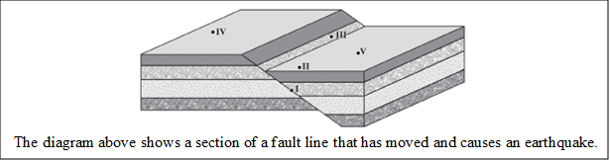

7. In the diagram shown above, the earthquake’s focus is labeled

  - I
  - II
  - III
  - V

8. The area that would most likely suffer the greatest damage as a result of ground vibrations caused by the earthquake is labeled

- II
- III
- IV
- V

9. Seismic waves travel out from the focus

- Straight down into the Earth
- Horizontally out over the surface
- Out in all directions like a sphere
- None of the above

Numerical Response 2

The Richter scale is a logarithmic scale; based on this information I know that a 5.0 Earthquake is _______ times more severe than a 3.0.

_____ _____ _____ _____

Use the following image to answer the next question
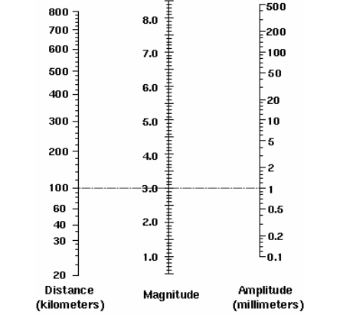

10. If the Seismograph was 400 km from the epicenter, and the amplitude there was 5 cm what
would be the strength of the Earthquake?

        - 5.8
        - 5.4
        - 5.1
        - 4.6

Use the following picture to answer the next question

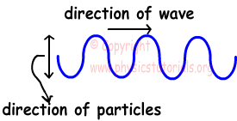

11. Which wave type does the picture above represent?

        - Primary waves which are longitudinal waves
        - Primary waves which are transverse waves
        - Secondary waves which are longitudinal waves
        - Secondary waves which are transverse waves

12. Which order do the waves arrive at the seismic station

- S waves, P waves, Surface waves
- P waves, S waves, Surface waves
- Surface waves, P waves, S waves
- Surface waves, S waves, P waves
13. A P wave can be described as

        - A series of compressions and expansion
        - A series of compressions and troughs
        - A series of crests and expansions
        - A series of crests and troughs

14. P-waves are able to travel through

        - Solids, liquids and gases
        - Solids and liquids
        - Solids only
        - Liquids only

Use the following picture to answer the next 2 questions

15. Which of the areas above indicates where we would only find P-waves?

        - A
        - B
        - C
        - D

- What is the reason why we find only P-waves in the area indicated above?

        - Because the inner core is liquid
        - Because the outer core is solid
        - Because the outer core is liquid
        - Because the inner core is solid

- P-waves are only found in area

        - C because of reflection
        - C because of refraction
        - B because of reflection
        - B because of refraction

Use the following information to answer the following two questions

Numerical Response
3.

- Using the information above, which numbers correctly identifies the layers of the Earth that are solid?

        - 1 and 2
        - 1 and 3
        - 2 and 3
        - 3 and 4

- Which of the following layers is the thinnest?

        - Asthenosphere
        - Core
        - Lithosphere
        - Mesosphere

- Which of the following is not evidence for plate tectonics?
        - Mountains
        - Paleomagnetism
        - Volcanoes and earthquakes
        - All of the above are evidence for plate tectonics
Use the following picture to answer the next two questions

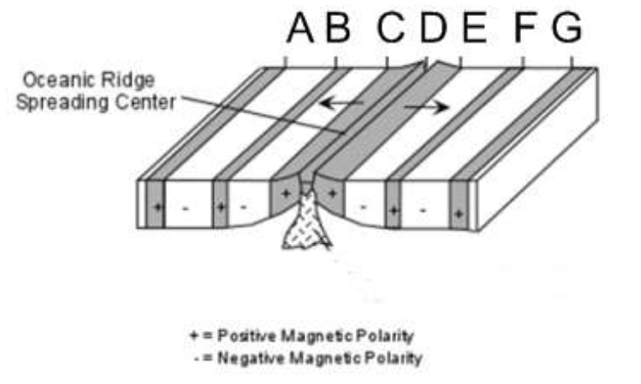
- Which of the following bands of rock would be considered the youngest?

        - A
        - B
        - C
        - D

- Which of the following pairs would indicate rock bands with the same age?

        - A and B
        - C and D
        - C and F
        - A and G

- Convection is the driving force for plate tectonics. Convection occurs because

        - Warmer material has a higher density
        - Warmer material has a lower density
        - Colder material has a higher density
        - Density has nothing to do with convection

24. What is currently believe to be the driving force for convection inside the Earth?

        - Radioactivity
        - The spinning inner core
        - The spinning outer core
        - The increase in pressure

Use the following information to answer the next three questions
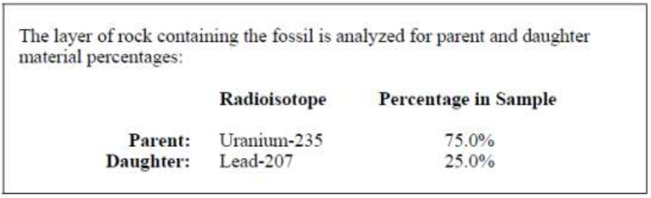

25. The percentages of radioisotopes shown above indicate that the number of half-lives elapsed by uranium-235 is

        - 0.25
        - 0.50
        - 1.0
        - 2.5

Use your recorded answer from Multiple Choice 25 to answer Multiple Choice 26.*

26. Based on the data obtained in the analysis, the age of the rock layer containing the fossil is

        - 1.76 × 10⁸ years
        - 3.52 × 10⁸ years
        - 7.04 × 10⁸ years
        - 1.76 × 10⁹ years

*You can receive marks for this question even if the previous question was answered incorrectly.

Use your recorded answer from Multiple Choice 26 to answer Multiple Choice 27.*

27. Based on the age of the rock layer, during which era of geologic time was the fossil formed?

        - Precambrian
        - Paleozoic
        - Mesozoic
        - Cenozoic

Numerical Response 4.

Use the following diagram to answer the next question
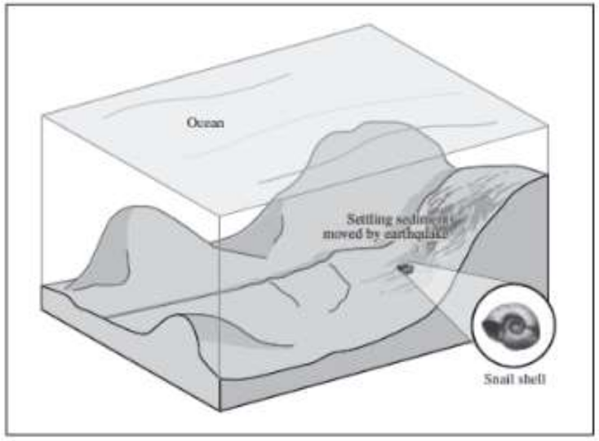

28. The diagram above depicts the fossilization of a snail. The process depicted would result in the formation of which of the following types of fossil?

        - Mold
        - Track
        - Burrow
        - Actual remains

29. Fossils of footprints and poop are examples of which type of fossil?

a. Trace
b. Mold
c. Tract
d. Actual remains

Use the following diagram to answer the next question
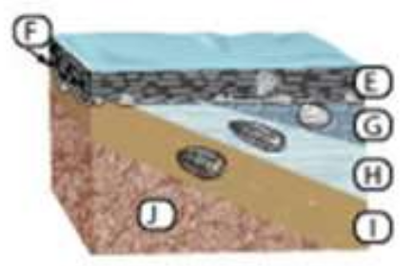

30. Using the information above which of the following letters represents the oldest fossil?

        - E
        - G
        - H
        - I

31. Evidence of mass extinctions is available in rock layers when

        - A new species appears in the fossil record
        - When a species disappears and never returns to the fossil record
        - When a species disappears and reappears some time later in the fossil record
        - When there is an unconformity

Numerical Response 5.

Using the information above place the Eras in order from longest to shortest
_____
_____
_____
_____

Use the following image to answer the next question
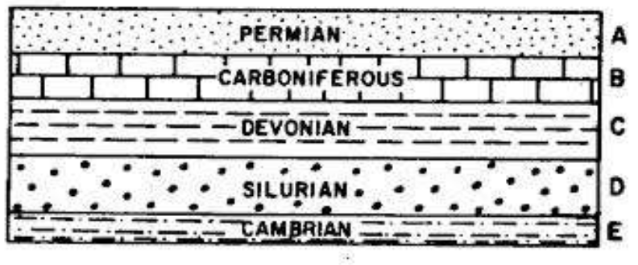

32. If I was looking at the rock strata above which dominant type of fossils would I expect to find in them?

        - Single cell organisms
        - Trilobites
        - Dinosaurs
        - Mammals
33. If I was looking for dinosaur fossils, which Era should I look in?

        - Precambrian
        - Paleozoic
        - Mesozoic
        - Cenozoic

34. During which Era was there an explosion due to the increase of oxygen in the environment?

        - Precambrian
        - Paleozoic
        - Mesozoic
        - Cenozoic

35. Why did the explosion referred to in question 29 occur?

        - Because oxygen is needed to create energy
        - Because oxygen allows animals to create more energy
        - Because life cannot live without high concentrations of oxygen
        - None of the above

36. A drumlin is

        - A tear drop shaped hill and is formed when a glacier advances over a moraine
        - A tear drop shaped hill and is formed at the edge of a glacier
        - A “reverse river” and is formed when ice melts and its water runs under a glacier
        - A “reverse river” and is formed when a chunk of ice breaks off the glacier

Use the following diagram to answer the next two questions
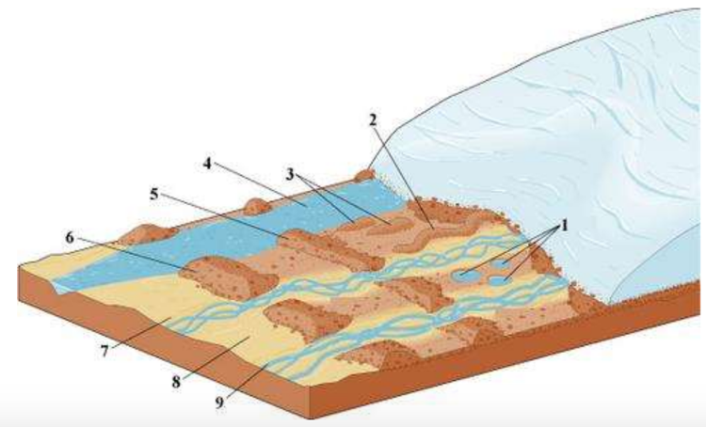

37. Which of the following numbers indicates the location of an esker?
        - 1
        - 2
        - 3
        - 4
38. According to the information above the glacier is

        - Advancing therefor the temperature must be increasing
        - Advancing therefor the temperature must be decreasing
        - Receding therefor the temperature must be increasing
        - Receding therefor the temperature must be decreasing

39. Inside an ice core a high oxygen content would indicate that

        - The temperature was warmer
        - The temperature was colder
        - There was more rainfall
        - There was less rainfall

40. Which of the following is not a possible cause for a mass extinction event?

a. Lunar energy output
b. Earth’s orbit around the sun
c. The inclination of Earth’s axis
d. Earth’s geography due to crustal movement

UNIT IV - CHANGES IN LIVING SYSTEMS

1. Define ecosystem, biosphere, biotic and abiotic.

2. Describe how energy flows through an ecosystem? Producers, decomposers and consumers.

3. Pyramid of numbers, energy and biomass? What they look like and characteristics.

4. Describe the process of biological magnification?

5. Describe how matter is cycled through the ecosystem.

6. Hydrological cycle - what is it, how does it work, parts to it.

7. Biogeochemical cycles - carbon, oxygen and nitrogen.

8. Describe the processes involved in the nitrogen cycle; nitrogen fixation, ammonification, nitrification, denitrification.

- What are the abiotic factors of an ecosystem; climatic, physiographic and edaphic factors, what are they and give examples.

10. What is a biome? How is it determined? Give some examples.

11. Define symbiosis, commensalism, mutualism, parasitism, predation, with examples.

12. What is intraspecific competition? Interspecific competition? Give an example of each.

14. Define niche and territory.

- Explain the concept of succession. Give examples of primary and secondary succession. Pioneer species? Climax species?

16. How does fitness of an organism related to adaptations and survival? Mutations?

17. How does speciation occur? Three processes are?

18. Explain the difference between convergent and divergent evolution.

19. How to population numbers change over time? Define biotic potential, environmental resistance, density-dependent factors, density-independent factors, carrying capacity. What factors limit population growth?

Science 20 Unit D Review Test Questions:

1. An ecosystem includes

A. non-living (abiotic) components only
B. living (biotic) components only
C. both biotic and abiotic components
D. physiographic components only

- When an angler decides to fish using a particular type of fly in a shaded part of a lake or stream, she demonstrates her understanding of

A. abiotic factors
B. biotic factors
C. stream ecosystems
D. all of the above

- The soil in a flower pot, the amount of water added to the pot, the amount of sunlight received by the plant, the amount and type of fertilizer given, and the temperature of the air surrounding the pot all make up the plant’s

A. abiotic factors
B. biotic factors
C. ecosystem
D. habitat

4. A rapid algal bloom can harm an aquatic ecosystem because

A. algae deplete the oxygen in the water
B. decomposing dead algae deplete the oxygen in the water
C. an extensive algal bloom blocks the sunlight for other organisms in the water
D. all of the above

5. Match each description with the appropriate term listed. Place your answer in the blank space given

i. ecosystem ii. habitat iii. nutrient
iv. algae v. abiotic factor vi. harmful algal bloom

___ a. an area where an organism lives
___ b. a physical, non-living part of an organism’s environment
___ c. any element or compound that an organism needs for metabolism
___ d. all the organisms in an area as well as the abiotic factors with which they interact

___ e. microscopic, photosynthetic organisms that play a vital role in aquatic ecosystems

___ f. a rapid growth of algae that can deplete oxygen and block sunlight required by
other organisms in an aquatic ecosystem

6. Decide whether each statement is true (T) or false (F). Place your answer in the blank space given.

- Water temperature is an abiotic factor in a lake ecosystem.
- Salt concentration in soil is a biotic factor for seed germination.
- A low concentration of salt does not affect bean seed germination.
- A high concentration of salt affects bean seed germination more than it affects sunflower seed germination.

7. Prairie-dog burrows help to aerate the soil so the prairie grasses grow well. Bison prefer to eat this rich vegetation in and around prairie-dog towns. This relationship is an example of

A. commensalism
B. mutualism
C. parasitism
D. none of the above

8. A tapeworm lives in the intestines of an animal and absorbs nourishment from its host. If the tapeworm multiplies enough, eventually the host becomes weak and may die of some contracted disease. This relationship is an example of

A. commensalism
B. mutualism
C. parasitism
D. none of the above

9. A peacrab lives in the shell of a feeding mussel. The peacrab eats tiny bits of
food that the mussel filters in. What is the relationship between the peacrab and
the mussel?

A. commensalism
B. mutualism
C. parasitism
D. predation

10. Match each description with the appropriate term listed. Place your answer in the blank space given.

i. biomass ii. ecology iii. population
iv. biological community v. symbiosis vi. competition

___ a. A group of organisms of the same species interbreed and live in the same area at
the same time.

___ b. In this interaction, two or more organisms compete for the same resource.

___ c. Interacting populations live in a certain area at the same time.
___ d. This describes the dry mass of all the living organisms that occupy a habitat.
___ e. This is a study of the interactions of living organisms with one another and with
their environment.
___ f. This long-lasting, ecological relationship benefits at least one organism of two
different species that live in close contact.

12. Decide whether each statement is true (T) or false (F). Place your answer in the blank space given.

___ a. Nutrients—such as nitrogen and phosphorus—that grasses need
to grow are converted from decomposing organic matter by
micro-organisms.
___ b. Prairie-dog communities benefit numerous other species.
___ c. Cowbirds become part of relationships classified as commensalism and
mutualism.
___ d. The great horned owl hunting the snowshoe hare at night has no effect on the
ability of the lynx to live off the snowshoe hare.

13. Green plants, algae, and tiny aquatic organisms that convert light energy and store it in the chemical bonds of organic molecules are called

A. consumers
B. herbivores
C. producers
D. primary consumers

14. Most people in Canada would be classified as

A. carnivores
B. herbivores
C. omnivores
D. producers

15. An energy pyramid differs from a biomass pyramid because

A. the two pyramids are inverted to each other
B. an energy pyramid does not show organisms at each trophic level
C. an energy pyramid has fewer organisms at the top trophic level
D. an energy pyramid shows the amount of energy at each trophic level, while a biomass pyramid shows the mass transferred at each trophic level

16. A food web is different from a food chain because a food web

A. does not begin with producers
B. shows the various trophic levels
C. does not show what each organism eats
D. is made up of various food chains that are part of an ecosystem

17. A northern pike is considered to be a tertiary consumer because

A. it eats algae
B. it is such a large organism
C. it eats primary consumers such as snails
D. it eats other organisms, such as frogs and other fish, that eat secondary consumers

18. Match each description with the appropriate term listed. Place your answer in the blank space given.

i. trophic level ii. primary consumer iii. omnivore
iv. decomposer v. secondary consumer vi. food chain
vii. food web viii. ecological pyramid

___ a. the pathway along which food is transferred from one trophic level to the next
trophic level
___ b. an organism that feeds on primary consumers
___ c. the division of species within an ecosystem based on their source of energy
___ d. an organism that eats both plants and animals
___ e. the interconnecting feeding relationships within an ecosystem
___ f. a small organism that breaks down complex, organic molecules into simpler
organic molecules
___ g. a diagram that shows the relative amount of energy, the number of organisms, or
the amount of matter contained at each trophic level in a food chain or food web
___ h. an organism that obtains its food by feeding on photosynthetic organisms

19. Decide whether each statement is true (T) or false (F). Place your answer in the blank space given.

___ a. An organism can only be at one trophic level in the energy pyramid.
___ b. A food chain always begins with the producers.
___ c. Another name for a secondary consumer is a carnivore.
___ d. A food web is made up of a number of food chains.

20. Explain the difference between a producer and a consumer.

21. In terms of the pyramid of numbers, explain why there are so few hawks and owls in a given area compared to the number of mice and prairie dogs that the hawks and owls feed upon.

22. An example of a biotic factor in an aquatic ecosystem is

A. a pH of soil equal to 6.5
B. a water temperature equal to 13.5° C
C. the presence of coyote tracks
D. the presence of white stem pondweed

23. An example of an abiotic factor that is common to both terrestrial and aquatic ecosystems is

A. the pH of water
B. the amount of cloud cover
C. soil characteristics
D. the water temperature

24. A soil temperature of 12.2° C at a depth of 10 cm is an example of which type of factor?

A. an abiotic factor in a terrestrial ecosystem
B. a biotic factor in a terrestrial ecosystem
C. an abiotic factor in an aquatic ecosystem
D. a biotic factor in an aquatic ecosystem

25. The carbon cycle begins with the process of

A. cellular respiration
B. oxidation
C. photosynthesis
D. transpiration

26. A growing forest is valuable because it

A. removes carbon dioxide from the atmosphere
B. releases carbon dioxide into the atmosphere
C. removes methane from the atmosphere
D. uses oxygen from the atmosphere

27. In the oxygen cycle, oxygen is

A. added to and removed from the atmosphere by photosynthesis
B. added to the atmosphere by decomposers and removed by photosynthesis
C. added to the atmosphere by cellular respiration and removed by photosynthesis
D. added to the atmosphere by photosynthesis and removed by cellular respiration and combustion

28. A farmer plants alfalfa (a type of legume) to add nitrogen to the soil on his farm. The process through which nitrogen gas is converted into ammonia is known as

A. denitrification
B. nitrification
C. nitrogen fixation
D. fertilizing

29. Match each description with the appropriate term listed. Place your answer in the blank space given.

i. nitrification ii. carbon sink iii. ozone
iv. biogeochemical cycle v. denitrification vi. nitrifying bacteria
vii. transpiration viii. humidity

___ a. a series of chemical reactions involved in the movement of elements and
compounds between living and non-living components of an ecosystem
___ b. a system that removes more carbon dioxide from the atmosphere than it returns
___ c. the atmosphere’s moisture content
___ d. the process of converting ammonia into nitrates or nitrites
___ e. a molecule comprised of three oxygen atoms
___ f. a type of soil bacteria that converts ammonia into nitrates and nitrites
___ g. the loss of water vapour from a plant through its leaves
___ h. the process of converting nitrates in the soil into nitrogen gas

30. Decide whether each statement is true (T) or false (F). Place your answer in the blank space given.

___ a. Energy flows in only one direction through the trophic levels.
___ b. About 90% of chemical energy is used by organisms at each level.
___ c. A burning forest is an example of a carbon source.
___ d. Soil bacteria that convert ammonia into nitrates and nitrites are known as
denitrifying bacteria.

31. The following illustrates the sequence of events that led to a decline in the caribou population due to habitat fragmentation.

I. Cleared forest areas attract moose to live in the area.
II. Human activities create open areas and cutlines throughout a habitat.
III. The caribou population declines due to increased predation.
IV. More wolves move into the area.
V. Cutlines and open areas allow wolves to spot and capture prey more easily.

The order of events beginning with habitat fragmentation and resulting in a decline in the caribou population is

A. I, II, III, IV, V
B. V, I, II, IV, III
C. II, I, V, IV, III
D. II, III, I, IV, V

32. Match each description with the appropriate term listed. Place your answer in the blank space given.

i. biodiversity ii. habitat destruction
iii. invasive species iv. habitat fragmentation

___ a. a species introduced to an area by human action which expands to threaten the
area’s variety of life
___ b. the conversion of formerly continuous habitat into patches separated by non
habitat areas
___ c. the variety of life in all its forms
___ d. the permanent alteration of vital characteristics in an organism’s habitat

33. Decide whether each statement is true (T) or false (F). Place your answer in the blank space given.

___ a. Only an animal can be an invasive species.
___ b. Clearcutting an area of forest results in habitat destruction.
___ c. The elimination of one key species can affect the health of an entire ecosystem.

34. Give one reason why an invasive species is able to establish itself in a new area.

35. An example of a pioneer species is

A. wheat
B. ferns
C. bees
D. buffalo

36. A reason for primary succession to occur in an area of Alberta today is from the effects of

A. glaciation
B. clearcut logging
C. mountain formation
D. the controlled burn of a forest

37. Primary succession can be observed through aquatic succession by noting

A. changes in the numbers and types of organisms
B. the appearance of a particular organism
C. the disappearance of a particular organism
D. that no changes occurred

38. Match each description with the appropriate term listed. Place your answer in the blank space given.

i. humus ii. primary succession
iii. pioneer species iv. climax community

___ a. This stable community results from the process of succession.
___ b. These simple and hardy plants first colonize barren ground or rock.
___ c. This organic component of soil is created from decomposed organisms.
___ d. This is the process of changing an environment from bare rock and a few species
to a complex community with many species.

39. Secondary succession is most easily observed

A. after a forest fire
B. after the winter snow has melted
C. after a rainstorm
D. on a lava flow

40. What is the major difference between primary succession and secondary succession?

41. Describe what effect clearcutting an area of forest would have on the deer population.

42. A line graph of the increase in the human population for both Alberta and Canada would be

A. a horizontal line
B. a straight line rising to the right
C. a straight line decreasing to the right
D. a curved line rising to the right

43. Fifty moose live in a particular region in northwestern Alberta. The factors which affect the population within the region are

A. only the number of births and the number of deaths
B. only immigration and emigration
C. only the number of births and the amount of immigration
D. births, deaths, immigration, and emigration

44. The population of grouse in a particular region increases and decreases every five years. The graph of the grouse population over 20 years would have the shape of

A. a straight line
B. a J-curve
C. an S-curve
D. an exponential curve

45. A population of sea monkeys in a fish tank is an example of a closed population because

A. the birth rate of the sea monkeys is low
B. the carrying capacity of the fish tank is limited
C. there is a limited amount of food in the fish tank
D. there is no sea monkey immigration or emigration

46. Match each description with the appropriate term listed. Place your answer in the blank space given.

i. closed population ii. doubling time iii. carrying capacity
iv. open population v. S-curve vi. exponential curve

___ a. the maximum number of individuals that can be sustained for an indefinite time in
a given ecosystem
___ b. the distinctive curve for a population that is increasing rapidly
___ c. the amount of time it takes for a population to double in size
___ d. a group of organisms that exists in a setting where immigration and emigration do
not occur
___ e. the distinctive curve of the graph for a population limited by factors such as
disease, competition, and famine
___ f. a group of organisms that exists in a setting where births, deaths, immigration,
and emigration all affect the population numbers

47. Snail fossils are a good species for the fossil record because

A. snail shells are well preserved
B. snails exist in a wide variety of environments
C. snails have survived throughout Earth’s history
D. all of the above

48. Charles Darwin theorized that finches on the Galapagos Islands developed different beak types because the finches

A. came from various places with these different beak types
B. developed different beak types due to interbreeding
C. developed different beak types because they needed to adapt to the different types of food available
D. developed different beak types so they could defend themselves

49. On which of the following statements did Darwin base his theory of natural selection?

A. There is variation among individuals with respect to any trait in a population.
B. Organisms usually produce more offspring than can survive.
C. Organisms within a population compete for limited resources.
D. All of the above are correct.

50. The human arm, a whale flipper, and a bat wing are examples of

A. the theory of natural selection
B. Darwinian fitness
C. homologous structures
D. Lamarck’s theory of evolution
51. Soot deposits on the buildings and trees around Manchester, England, favoured the survival of the black moth over the peppered moth. A change in conditions in the area that favoured a return to a majority of peppered moths was

A. the removal of trees
B. the elimination of pollution
C. an introduction of more birds
D. a decrease in the bird population

52. Match each description with the appropriate term listed. Place your answer in the blank space given.

i. theory of evolution ii. asexual reproduction
iii. Darwinian fitness iv. theory of natural selection

___ a. the reproductive success of an organism
___ b. a theory stating that the nature of a population gradually changes form over time
___ c. the production of identical offspring from a single parent cell by budding, by the
division of a single cell, or by the division of the entire organism into two or more parts
___ d. a theory stating that evolution takes place because more organisms are produced
than can survive, and only the organisms best suited to their environment survive to reproduce and pass on their advantageous traits to their offspring

53. Explain the difference between Darwin’s explanation of how giraffes got long necks and Lamarck’s explanation. In your explanation, describe how each scientist would explain how giraffes got long necks.

