Physics 30 – Lab Manual

Table of Contents
Background Information:
Typical Lab Format Guidelines………………………………………………………………..….5
Graphing Guidelines…………………………………………………………………………..…..9
Significant Digits………………………………………………………………………………...11
Labs:
Unit A: Momentum and Impulse
Conservation of Momentum in 1D ………………………………………………………...……13
Conservation of Momentum in an Air Table ………..………………………….....……………16
Unit B: Forces and Fields
Nature of Charge & the Electroscope ...…………………………………………………………18
Coulomb’s Law Lab (Version 1) ………………………………………………………………..21
Coulomb’s Law Lab (Version 2) ………………………………………………………………..23

Coulomb’s Law and Curve Straightening Lab .…………………………………………………25
Lenz’s Law Lab …………………………...…………………………………………………….29
Charge to Mass Ratio of the Electron …..……………………………………………………….31
Determining the Magnetic Field Strength .…………………………………………..……….…36
Unit C: Electromagnetic Radiation
The Optics of Concave and Convex Mirrors ……………………………………………………39
The Optics of Convex Thin Lenses …...……………………………………………….………..42
The Wave Nature of Light……………………………………………………………………….45
Determining the Index of Refraction ..……………………………………………..……………49
Investigation: Diffraction ……………………………………………………………………….52
Determining the Wavelength of EMR…………………………………………………………...54
Unit D: Atomic Physics
The Photoelectric Effect Lab ……………………………………………………………………56

A Millikan-Like Oil-Drop Lab …………………………………...……………………………..60
Emission Line Spectra Observation Sheet .……………………………………………………...62
Sample Data…………………………………………………………………………………63
Performing a Regression on the TI Graphing Calculator………………..….67
Creating a Graph and Calculating Slope in Excel……………………………..68
Formula Sheet……………...……………………………………………………………71
Double Protractor…………...……………………………………….…………………73

The Typical Physics Lab Format
Purpose: a statement of why the lab activity is being performed. Ex) “The purpose of this activity is to measure the acceleration due to gravity close to the surface of the Earth”.

Problem: That which the lab activity will answer. The question can be qualitative, investigating a relationship between two or more quantities (i.e. what is the relationship between angle of incline and range of a cannon) or quantitative, providing a numerical answer to the question (i.e. What is the maximum range of a cannon?).

Hypothesis: A hypothesis (plural: hypotheses) is a prediction about the outcome of a scientific investigation. Like all predictions, hypotheses are based on a person’s observations and previous knowledge or experience. In science, hypotheses must be testable. That means that researchers should be able to carry out an investigation and obtain evidence that shows whether the hypothesis is verified or falsified (true or false).

The hypothesis can address what the relationship between variables will be for a qualitative lab, or a quoted numerical value from an accepted source in a qualitative lab. If the hypothesis includes a number, you must explain where that value came from and why it was chosen. Do not just make a value that seems reasonable or make a guess. The hypothesis should begin to answer the question. It is okay if your hypothesis turns out to be wrong, you will address this in the evaluation of your lab report.

Be careful with the wording of your hypothesis. It should be a confident statement of what you believe will happen in the lab.

Not Acceptable:

I think that the higher an object will drop from, the longer it will take to fall.

Acceptable:

The higher an object will drop from, the longer it will take to fall.

Design: A 1-3 sentence explanation of what will go on in the lab. This should give a brief flavor or idea of what will happen in the lab without all of the detail of a procedure. Include any diagram of the of the apparatus needed.

Variables: For every experiment, you should be able to list the variables. A variable is any factor that affects an experiment.

Variables can be classified into one of three groups:

- Manipulated variable (independent variable)

  - The variable chosen by the experimenter
  - The experimenter purposely changes this variable

- Responding variable (dependent variable)

  - The set of values the experimenter is trying to measure
  - Usually affected by a change in the manipulated variable

- Controlled variable

  - Those variables that are held constant (not allowed to change) during an investigation to make sure that the results are valid

Materials: a list of everything you used in the lab. Don’t include items like “pencil, paper, calculators” which you assume a prepared student would normally have.

Procedure: A step-by-step description explaining how your conducted your lab. Number each step so it is easy to follow. Include enough detail so another person with some background in physics could read the report and duplicate the result with the same or similar equipment. Keep the procedure as short and concise as possible without missing any important steps.

Data Tables: Data should be placed in table format, with column headings for each data set and units included in the titles. All data tables should have data recorded to the proper accuracy and number of significant digits: i.e. if you are measuring distance with a ruler with smallest increments of 0.01 m, all of your measurements should be to 0.01 m.

You should record all raw data that you collect in the lab. Do not omit any points because they do not “fit”. Later on, when you are completing your analysis and evaluation, you can decide whether a point was caused by error, and can disregard it at that time.

Examples of Data Tables:
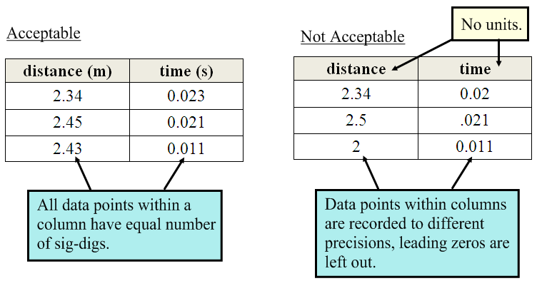

Analysis: This is the part of the lab where graphs are created and calculations are completed. Follow all graphing techniques described on page 9 and show all your work for the calculations.

You will often perform the same calculation repeatedly on many sets of data. In these cases, it is wise to show your work once in a sample calculation, showing how the calculation was performed, then complete the rest of the calculations in your calculator or on scrap paper and simply record the solutions in your report.

A common analysis calculation is the percent error calculation. Percent error is used when comparing a result to an accepted value. Use the following equation to calculate percent error:

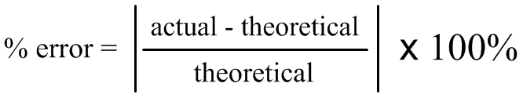

Where:

Actual = the value you calculated in the lab.
Theoretical – the accepted value, as published in a textbook.

*Note: the vertical lines indicate an absolute function. This function takes any negative number and makes it positive.

Ex) In a lab to measure a distance of exactly 5.00 cm, you measure 5.50 cm. The percent error is:

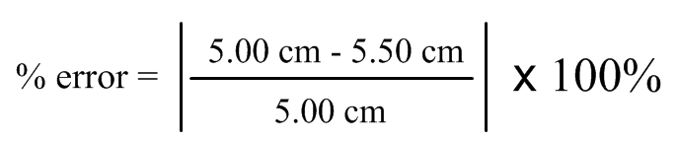
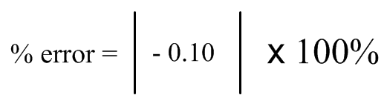
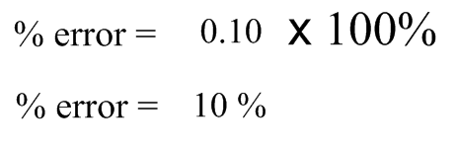

Insure that all calculations are complete to the proper number of significant digits and include all the proper units for all data points.

You will occasionally have to answer additional analysis questions posed your instructor in this section of the lab report, sometimes in place of a evaluation.

Evaluation: This is the most important part of the lab report. It should contain the following information:

1. Short summary of the lab: this can be one sentence describing what happened in the lab.
2. Statement of whether the hypothesis was correct or not. Remember, there is some wiggle room here; if the hypothesis stated that it takes 1.43 seconds for an object to fall 10 m, and the calculated value in the lab was 1.50 seconds, the hypothesis is not necessarily wrong. In fact, that is quite an accurate result, depending on equipment used. You should state your percent error here as well.
3. A description of why the hypothesis was correct or incorrect.
4. Sources of error: there is error in any lab ever conducted. We cannot eliminate it, we can only reduce it as much as possible.

Sources of error can occur at any point in the scientific process. When you are evaluating an experiment, critically examine each step. For example, some common questions when considering sources of error are

- Were the measuring instruments properly calibrated?
- Was there any room for subjectivity in recording data?
- Were the measuring devices as precise as needed?
- Was there a loss of energy in the system?

5. Improvements: list any improvement that could give more accurate results if the lab was conducted again.

Again, a student (or your teacher!) with a good background in physics should be able read your evaluation and understand everything that went on in your lab, and should be able to repeat your lab and get the same or similar results.

Graphing

Being able to graph data and make conclusions from that data is crucial for any student of physics. This is an essential skill you will not have success without, so be very diligent with any and all graphing!

Some guidelines to follow for graphing data:

1. Title: Printed at top of graph and underlined. It should be titled in a "y variable vs. x variable" format.

2. Label the axes: manipulated variables go on the x-axis, responding on the y-axis. INCLUDE UNITS! Use a ruler to draw of the axis if you are making your graph on graph paper.

3. Increments: use the entire graph paper and choose appropriate increments that will make an easy to read graph. The increments do not have to start at zero and the increments for the x- and y-axis can be different (i.e. the y-axis can go up by 5s and the x-axis can go up by 2s).

4. Plotted Points: always graph your plotted points in pencil and circle your points so they are easy to read. These points are used to create a line of best fit only and are never used for slope calculations.

5. Line (Curve) of Best Fit: Determine the general shape of the graph. If the graph is curved, draw a smooth curve going through as many points as possible. If the graph is linear, use a ruler and try to put the same number of dots above the line as below the line. DO NOT JUST CONNECT THE DOTS! The line of best fit is a regression used to make your raw data fit neatly into an linear mathematical equation.

6. Finding Slope: Finding the slope is a powerful tool for determining unknowns in the lab. Use the following equation to determine the slope of a linear graph:

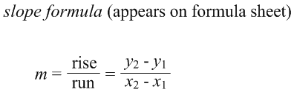

You will use this equation to find the slope of your line of best fit. This means you must take points off of your line to calculate the slope, not data points that you plotted. If you were to use plotted points to calculate slope, you are only basing the slope on two trials from the lab. By choosing two points off of the line of best fit, you are taking into consideration all pertinent data points collected in the lab, as all pertinent points have an effect on the line of best fit.

When graphing, you may also need to interpolate or extrapolate:

- Interpolating: means to estimate a value between two data points.

- Extrapolating: means to estimate a value beyond the data points.

Exemplar: A curling stone is slid down an ice sheet towards the house in a game of curling. Any forces of friction are ignored. At measured time intervals, measurements are taken for the distance the rock has traveled. Graphically analyze the movement of the rock.
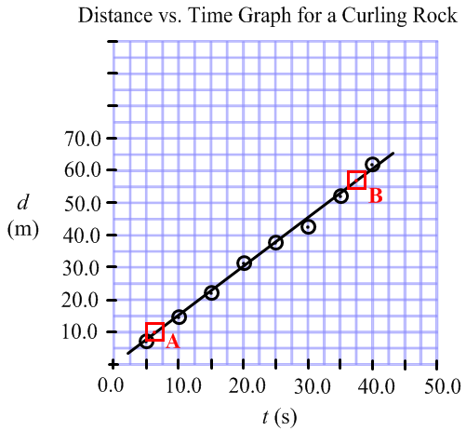
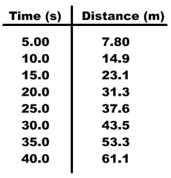

Slope:

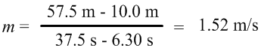

The average speed of the rock was 1.52 m/s.

Note, on the graph above:

- The increments did not go up by the same amount. This is okay.
- Not every single increment is shown, for clarity. This is okay too.
- The graph covered as much of the grid as possible.
- The line of best fit has about the same number of points above as below it and does not necessarily need to pass through the origin.
- Two points (A and B) which were points from the line, not from actual plotted points, were chosen for the slope calculation.
- The slope calculation keeps the correct number of significant digits.

Significant Digit Rules:

- Sig digs is a system of rules used to determine how many decimal places answers should be rounded to.
- The system ensures that the answer to a problem is never more precise than the measurements used to begin the problem.
- In the lab setting, we determine the number of significant digits from the measuring devices we are using.

Guidelines for determining Sig Digs in the Lab:

- The number of sig-digs in a measurement is the same as the smallest increment one can measure with the measuring device.

Ex) A 30 cm ruler can measure a maximum of 2 sig digs (ex. 29 cm) if centimetres is the smallest increment. It could measure a maximum of 3 sig digs (ex. 29.5 cm) if millimetres is the smallest increment.

Ex) A stop-watch may record to the nearest hundredth. Therefore, a time measurement such as 6.00 s is three sig digs.

Determining the # of Sig Digs:

- All digits in a number are significant. This includes digits before and after the decimal. Scientific notation does not count.

Examples:
  - 5 1 sd
  - 4.5 2 sd
  - 89.9 3 sd
  - 3.2 x 10⁻³ 2 sd

- Zeros to the left of the first digit are only place holders and do not count as sig digs.

- Zeros to the right of the first digit or inside values count as sig digs.

Examples:
  - 0.005 1 sd
  - 1.005 4 sd
  - 0.0050001 5 sd

Significant Digit rules to not apply to:

  - Exact numbers
    - The mass of 3 goats is 24.5 kg, what is the mass of each goat...the 3 does not count as a sig dig.

  - values from the data booklet
    - The acceleration due to gravity, 9.81 m/s², does not count for sig digs.

Operations with Sig Digs: Adding or Subtracting:
Your answer should contain the same number of digits after the decimal as the smallest number of digits after the decimal in the question.

Ex) 4.5 + 7.85 + 6.98247 = 19.3324 Answer with Sig Digs: 19.3

Ex) 5.4 – 3.24 = 2.16 Answer with Sig Digs: 2.2

Operations with Sig Digs Multiplying and Dividing:

When multiplying or dividing, you must have the same number of sig digs in your final answer as the least number of sig digs in your question.

Ex) 2.45 ÷ 1.432= 1.71089… Answer with Sig Digs: 1.71

Ex) 5.8 x 10² * 1.255 = 727.9 Answer with Sig Digs: 7.3 x 10²


P30 Unit A: Conservation of Momentum in 1D
/17
Name: ____________

Date: ____________

Question: Does the air-track/cart system represent an isolated system?

Hypothesis: (2 marks)
………………………………………………………………………………………………………
………………………………………………………………………………………………………
………………………………………………………………………………………………………
………………………………………………………………………………………………………

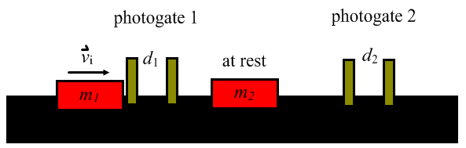
Design: An air-track is set-up with two identical air-track cars. The car each have a bit of tape/Velcro® on them, allowing them to hit and stick together. One of the cars will start at rest to simplify the measurements. The velocities of the cars are measured before and after collision using a photogate timer.

Variables: (1 mark)

Controlled: ……………………………………………………………………………

Manipulated: ……………………………………………………………………………

Responding: ……………………………………………………………………………

Materials:

- Air-track and air-source
- Air-track cars
- Tape/Velcro®
- Two photogates
- Triple-beam balance

Procedure: (2 marks)

………………………………………………………………………………………………………
………………………………………………………………………………………………………
………………………………………………………………………………………………………
………………………………………………………………………………………………………
………………………………………………………………………………………………………
………………………………………………………………………………………………………
………………………………………………………………………………………………………
………………………………………………………………………………………………………
………………………………………………………………………………………………………

Data Table: (3 marks)

m₁ = ______ m₂ = _______ d₁ = _______ d₂ = ________

 | Before Collision |  |  | After Collision
Trial | t₁ | v₁ | p_{i} | t₂ | v₂ | p_{f}
1
2
3
4

Analysis:

Sample velocity calculation: (1 mark)

Sample momentum calculation (before): (1 mark)

Sample momentum calculation (after): (1 mark)

Evaluation: Briefly summarize the lab, answer the question, state whether the hypothesis was correct and why, explain reasons for any loss of momentum, give improvements on the lab and any sources of error. (6 marks)

………………………………………………………………………………………………………
………………………………………………………………………………………………………
………………………………………………………………………………………………………
………………………………………………………………………………………………………
………………………………………………………………………………………………………
………………………………………………………………………………………………………
………………………………………………………………………………………………………
………………………………………………………………………………………………………
………………………………………………………………………………………………………
………………………………………………………………………………………………………
………………………………………………………………………………………………………
………………………………………………………………………………………………………
………………………………………………………………………………………………………
………………………………………………………………………………………………………
………………………………………………………………………………………………………
………………………………………………………………………………………………………
………………………………………………………………………………………………………
………………………………………………………………………………………………………
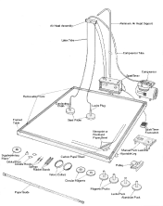
P30 Unit A –Air Table Lab
Name: ______________
Date: ______________
/16

Problem: How does the momentum of a two-body system in the x and y dimensions compare just before and just after collision?

Hypothesis: (1 mark)
………………………………………………………………………………………………………………………………………………………………………………………………………………………………………………………………………………………………………………………
Design: A collision between two pucks is recorded using an air-table. The air-table reduces the effects of friction, allowing for more accurate results. The pucks place a spark on a sheet of paper at measured intervals, allowing for velocity calculations to be made.

Variables: (1 mark)

Controlled: ……………………………………………………………………………

Manipulated: ……………………………………………………………………………

Responding: ……………………………………………………………………………

Materials and Equipment:

- Air table with pucks
- Spark timer
- Ruler or meter stick
- Protractor

Procedure:
- Determine the mass of the two pucks using the triple beam balance. Record the mass the evidence section of this report.
- Place a sheet of carbon paper on the glass of the air table (carbon paper can be reused from group to group).
- Place a piece of white paper over the carbon paper and place the pucks on the paper.
- Choose a setting for the spark timer and record the setting in the evidence section of this report.
- Turn on the air pump and the spark timer and place the pucks on the table. With one group member pressing the hand-pedal, have two other group members push the pucks on a collision course.
- Take off the white paper and examine the dots. They should be fairly clear.
- Repeat if needed.

Evidence:
Average mass of a puck = ( _______ ) + ( _______ ) / 2 = ________ g
Spark timer setting = _________ ms.
Analysis:
Sample resultant velocity (v_{r} ) calculation. (1 mark)

Sample resultant momentum (p_{r}) calculation. (1 mark)

Sample horizontal momentum (p_{x}) calculation. (1 mark)

Sample vertical momentum (p_{y}) calculation. (1 mark)

Data Table: (4 marks)
Before Collision |  |  |  |  | After Collision
 | A | B | total |  | A | B | total
v_{r} |  |  | n/a |  |  |  | n/a
p_{r} |  |  | n/a |  |  |  | n/a
p_{x}
p_{y}
*velocities are in m/s and momentums are in kgm/s.
Evaluation: Briefly summarize the lab, answer the question, state whether the hypothesis was correct and why, explain reasons for any apparent loss of momentum, give improvements on the lab and any sources of error. (6 marks)
………………………………………………………………………………………………………
………………………………………………………………………………………………………
………………………………………………………………………………………………………
………………………………………………………………………………………………………
………………………………………………………………………………………………………
………………………………………………………………………………………………………
………………………………………………………………………………………………………
………………………………………………………………………………………………………
………………………………………………………………………………………………………
………………………………………………………………………………………………………
………………………………………………………………………………………………………
………………………………………………………………………………………………………
………………………………………………………………………………………………………
………………………………………………………………………………………………………
………………………………………………………………………………………………………
………………………………………………………………………………………………………
………………………………………………………………………………………………………
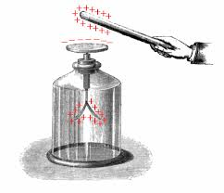
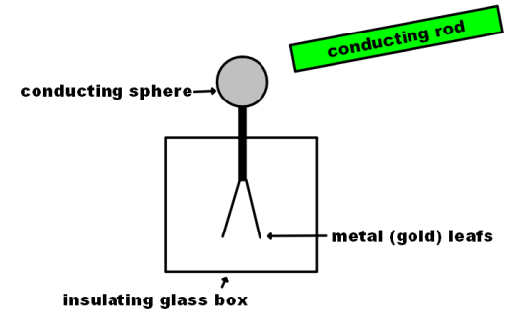
P30 Unit B:Nature of Charge & the Electroscope
Name: __________

Date: __________
Background: Developed in 1600 by British physicist William Gilbert, the electroscope is a simple device used to study electrostatics and the nature of charge (i.e. positive or negative charge).

As charge moves from a source into the conducting sphere, it distributes out over the metal leafs (gold is traditionally used as it is a great conductor), and the resulting interaction causes the leafs to move.

Italian Alessandro Volta championed the electrophorus in 1775. The device allows charge to be separated and stored on the metal disk.
/13

Question: How can an electroscope and electrophorus be used to:
- demonstrate methods of charge separation and transfer?
- determine the nature of the charge on a vinyl or glass charged rod?

Procedure:

1. Obtain an electroscope and a vinyl (black) rod as well as a glass (clear) rod. Obtain an object to charge the rods with (animal fur or fabric work well).

2. Rub one of the rods with the fur to charge the rod by friction. Touch the rod to the sphere. Repeat 3 or 4 times. Try dragging the length of the rod across the top of the sphere as well as just touching it.

Questions: (3 marks)

What type of charge transfer is this? ____________________________

What will the nature of the charge on the rod be compared to
the nature of the charge on the electroscope after contact? ____________________________

Which method of charging seemed to work better: touching the rod to the sphere or dragging it? Why is this?
………………………………………………………………………………………………………………..
………………………………………………………………………………………………………………..………………………………………………………………………………………………………………..
………………………………………………………………………………………………………………..

3. Draw two diagrams below to show the movement of charge from the rod to the electroscope. For the first diagram, assume the rod starts with a positive charge. For the second diagram, assume the rod starts with a negative charge. (2 marks)

4. Charge the rods again as in step 2. Hold each rod near the charged sphere, but do not touch it. Note the movement of the electroscope leafs.

Questions: (2 marks)

What method of separation of charge is this? ________________________________

What difference is noted when the different rods come near the charged electroscope?
………………………………………………………………………………………………………………..
………………………………………………………………………………………………………………..

5. Draw two diagrams showing the movement of charge as each rod moves towards the charged electroscope. Assume the electroscope is charged negatively and that each rod has a different nature of charge. (2 marks)

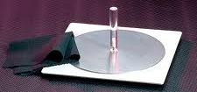
6. Charge the electrophorus by rubbing the white plastic base with a cloth or fur. While holding by the insulated handle, place the metal place on the base, let go of the handle and touch the metal with your thumb. Grab the handle again and remove the plate. Touch the plate to the electroscope. *NOTE: the device works because there is a small gap between the metal surface and the base, meaning portions of the two materials to not touch but only come close to each other.

Questions: (2 marks)

What type of charge transfer is this? ____________________________

What will the nature of the charge on the plate be compared to
the nature of the charge on the base after you contact the
plate with your thumb? ____________________________

7. Draw two diagrams showing the movement of charge in the electrophorus. In the first diagram show the separation of charge as the neutral plate is placed on top of (but not completely touching) the base. In the second diagram, show the movement of charge as your thumb contacts the plate. (2 marks)

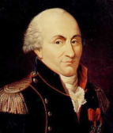
P30 Unit B: Coulomb’s Law Lab (Version 1)
Name: __________

Date: __________
/15
Problem: What is the experimentally determined charge product on two charged spheres?

Hypothesis: (State a probable range for charge on two ping-pong ball sized objects charged by friction. (1 mark)

………………………………………………………………………………………………………
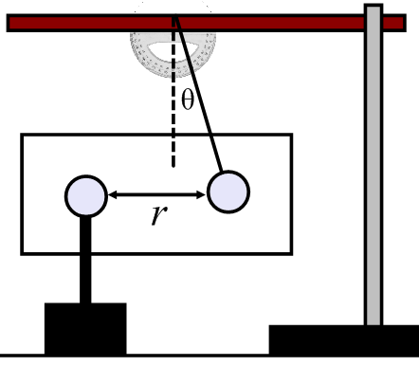
Design: A neutral pith ball is suspended from an insulating thread in front of a protractor as shown in the diagram. The ball is touched to a Van der Graff generator and an unknown charge is given to it, creating an electrostatic repulsion. The angle of displacement between the spheres is measured as the distance between them is varied. A digital photo will be taken to make measurements easier to take.

Variables: (1 mark)

Controlled: ……………………………………………………………………………

Manipulated: ……………………………………………………………………………

Responding: ……………………………………………………………………………

Materials and Equipment:

- Pith balls
- Thread
- Stand and metre stick
- Van de Graff generator
- Protractor
- Digital Camera and tripod

Procedure:

1. Set up the apparatus as shown. There will be one apparatus per class.
2. Place a charge on the pith ball through conduction by touching it to the Van de Graff generator.
3. Place the pith ball a measured distance r from the suspended pith ball.
4. When the system is at rest, take a photograph. Use the photograph to measure the angle θ.
5. Repeat, varying the distance r.
6. Record your observations on the data sheet provided.

Data: (2 marks)

Distance, r (m) | Angle, θ (°) | F_{e} (N)

Analysis:

Free body diagram of the forces acting on the suspended pith ball. (1 mark)

Sample calculation for electric force on suspended pith ball. (2 marks)

NOTE: THIS DATA WILL BE USED IN THE FUTURE TO CALCULATE q THROUGH CURVE STRAIGHTENING TECHNIQUES.

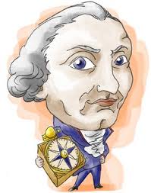
P30 Unit B: Forces and Fields
Coulomb’s Law Lab (Version 2)
Name: __________

Date: __________
/15
Problem: What is the experimentally determined charge product on two charged spheres?

Hypothesis: (State a probable range for charge on two ping-pong ball sized objects charged by friction. (1 mark)

………………………………………………………………………………………………………
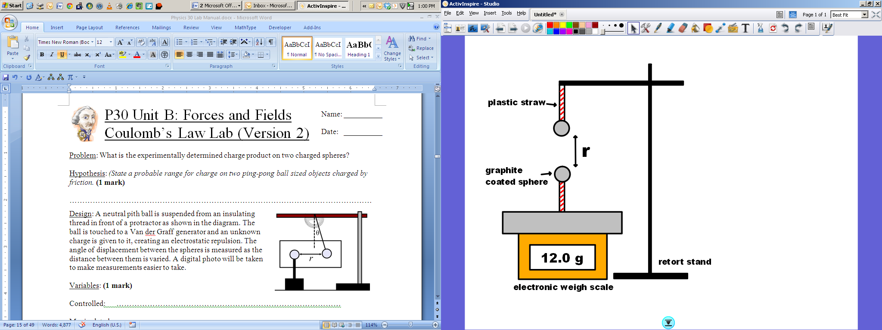
Design: A charged graphite coated sphere is fixed to a zeroed electronic weigh scale by an insulating plastic straw. A second, equally charged sphere is suspended a separation of r vertically above the first sphere. The electric force between the spheres can be measured using the readout on the scale. Various measurements of r and the mass readout on the scale, m, are made to determine the charge on each sphere.

Variables: (1 mark)

Controlled: ……………………………………………………………………………

Manipulated: ……………………………………………………………………………

Responding: ……………………………………………………………………………

Materials:
- Two identical graphite coated spheres (foam or ping-pong balls)
- Electronic weigh scale
- Retort stand and clamp
- Plastic drinking straws
- Tape to fasten straws to balls, stand
- Ruler
- Source of charge (balloon, electrophorus, Van de Graaff, etc)
Procedure:
1. Assemble the apparatus as shown in the diagram. Zero (tare) the scale so the reading is set to zero grams.
2. Charge the sphere fixed to the scale. Carefully bring the movable sphere into contact with this sphere.
3. Position the movable sphere high enough above the fixed sphere so that the reading on the scale is 0 g. Slowly reposition the movable sphere towards the fixed sphere, recording values of r and the mass readout, m.
Data Table: (3 marks)
Separation Distance, r (m) | Mass Readout (g) | Electric Force, $\overset{⃑}{F_{e}}$ (N)

Analysis:
Sample calculation for the electric force acting between the two spheres. (2 marks)

NOTE: THIS DATA WILL BE USED IN THE FUTURE TO CALCULATE q THROUGH CURVE STRAIGHTENING TECHNIQUES.


P30 Unit B: Coulomb’s Law and Curve Straightening Lab
Name: __________

Date: __________

Background: one of the most important skills to be learned in Physics 30 is how to take a graph of collected data and get more information from it. This procedure (which you started in Physics 20) is called graphical analysis. In this lab activity, you will use the data from your previous Coulomb’s Law lab to calculate the charge present on each pith ball.

The following is an example we will work through in class to show this procedure (taken from an old diploma question):

In-Class Practice
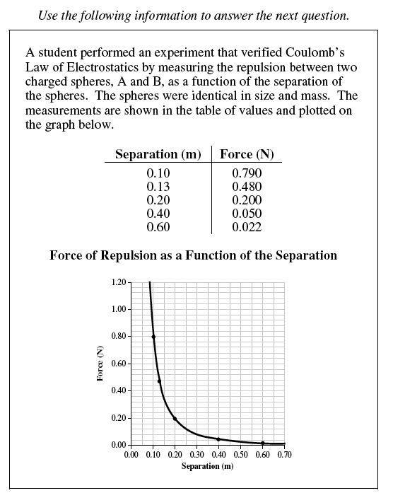

- Show that the results verify Coulomb’s Law by manipulating the data and providing a new table of values that, when plotted, will produce a straight-line graph.

- Plot the new data with the responding variable on the vertical axis.



- Calculate the slope of your graph.

- Using the slope value, or another suitable averaging technique, determine the charge on sphere B if the charge on sphere A is 3.08 x 10^{–7} C.


Analysis: (continued from previous lab)

In your Coulomb’s Law Pith Ball Lab, you collected data for plotting a graph of force vs. separation distance for the apparatus. Using the graph from your lab and the line straightening techniques learned today, create a straight line graph of your data from the lab and determine the experimental value of the product of the charges for the experiment.

Sample calculation for line straightening procedure (2 marks)

New data table for graphing, including appropriate units. (2 marks)

Separation Distance, r (m) | Electric Force, $\overset{⃑}{F_{e}}$ (N)

Complete straight-line graph (following graphing conventions displayed on page 9 of this manual). (2 marks)

Sample slope calculation (1 mark)

Determination of the charge product. (2 marks)

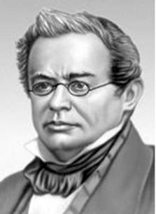
P30 Unit B: Lenz’s Law Lab (Electromagnetic Induction)
Name: __________

Date: __________
/12
Problem: What is the effect of a uniform magnetic field on a moving conductor (or vice-versa)?

Hypothesis: (1 mark)

………………………………………………………………………………………………………
………………………………………………………………………………………………………
………………………………………………………………………………………………………
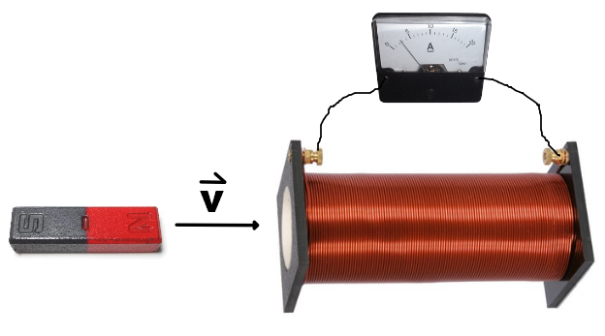
Design:
An air-core solenoid is attached via alligator clips to an ammeter. A bar magnet is then moved into and out of the solenoid. The resulting current measured on the ammeter is observed.

Materials:
- Magnet (bar or otherwise)
- Air-core solenoid
- Ammeter or galvanometer
Procedure:
1. Assemble the apparatus as shown above.
2. Move the north pole of the magnet in towards the solenoid. Note the direction in flow of current through the ammeter.
3. Move the north pole of the magnet out away from the solenoid. Note the direction in flow of current through the ammeter.
4. Repeat steps 2 and 3 above, this time using the south pole of the magnet.

Analysis:
On each diagram below, indicate the direction of the magnet movement and direction of current through the ammeter for each of the four scenarios investigated above. On the diagram, also draw in: i) the direction of the magnetic field produced by the magnet, the direction of the magnetic force acting on the magnet from the solenoid and the magnetic polarity of the solenoid during movement. (2 marks each)
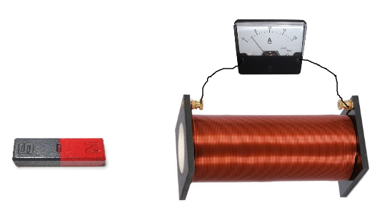

Evaluation: Choose one of the scenarios above and explain the direction of the induced current using the principles of induction and Lenz’s law. (3 marks)
………………………………………………………………………………………………………
………………………………………………………………………………………………………
………………………………………………………………………………………………………
………………………………………………………………………………………………………
………………………………………………………………………………………………………
………………………………………………………………………………………………………
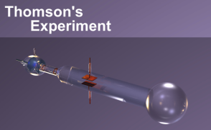
P30 Unit B: Charge to Mass Ratio of the Electron Lab
/25
Name: _________

Date: _________
Problem: What is the charge to mass ratio of the particles emitted from a cathode ray tube (CRT)?

Hypothesis: (1 mark)

………………………………………………………………………………………………………
………………………………………………………………………………………………………
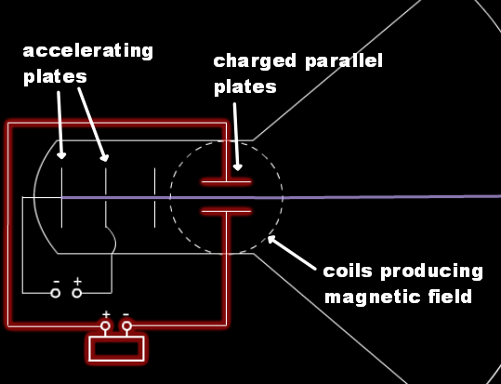
Design: In the charge to mass ratio experiment, a beam of particles called a cathode ray (now known to be electrons) are accelerated through charge parallel plates into an area of mutually perpendicular electric and magnetic fields. By setting the electric and magnetic forces equal to one another and observing no particle deflection, the charge to mass ratio of the particles can be determined.

Variables: (1 mark)

Controlled: ……………………………………………………………………………

Manipulated: ……………………………………………………………………………

Responding: ……………………………………………………………………………

To access the lab go to:
http://kcvs.ca/details.html?key=thomsonsEMExperiment

- Click on the link marked “Run Applet”
- Take a careful look at that picture, then click “Start”.

Analysis:

1. In the applet, set the voltage at +200 V.

a) Describe the motion of the cathode ray between and after the horizontal plates. (1 mark)
………………………………………………………………………………………………………
………………………………………………………………………………………………………
b) State two observations that suggest cathode rays are not noticeably affected by gravity. (1 mark)
………………………………………………………………………………………………………
………………………………………………………………………………………………………
c) What does the motion of the cathode rays indicate about their nature? (1 mark)
………………………………………………………………………………………………………
………………………………………………………………………………………………………
d) What is the direction of electric field between the plates. (1 mark)
………………………………………………………………………………………………………
………………………………………………………………………………………………………
2. Sketch a few diagrams to show how the horizontal and vertical components for the velocity of a cathode ray particle change when traveling between the plates. [A gravitational analogy of a ball thrown horizontally may help.] (1 mark)

3. Sketch a diagram starting with a dot representing a cathode ray particle and label: direction of the electric field, velocity of the particle and direction of the electric force. (1 mark)

4. If the plates are separated by a distance of 1.5 cm, calculate the value of the electric field. [Check your answer by selecting Field Values in the Options menu.] (1 mark)
………………………………………………………………………………………………………
………………………………………………………………………………………………………
………………………………………………………………………………………………………
………………………………………………………………………………………………………
5. What equation would you use to calculate the magnitude of the electric force? (1 mark)
………………………………………………………………………………………………………
………………………………………………………………………………………………………

6. In the Thomson applet, set the voltage at 0 V and move the slider for the current to the right.

a) How does the magnitude of the magnetic field change as the current changes? (1 mark)
………………………………………………………………………………………………………
………………………………………………………………………………………………………
b) Using the hand rule for coils, what is the direction of the current in the coil? (1 mark)
………………………………………………………………………………………………………
………………………………………………………………………………………………………
7. Move the current slider to the left (reversing the current as indicated by –I ).

a) What is the direction of the magnetic field now? (1 mark)
………………………………………………………………………………………………………
………………………………………………………………………………………………………
b) Sketch a diagram starting with a dot representing a cathode ray particle and label: direction of the magnetic field, velocity of the particle and direction of the magnetic force. (1 mark)

c) In this situation, what mathematical equation is used to calculate the magnitude of the magnetic force? (1 mark)
………………………………………………………………………………………………………
………………………………………………………………………………………………………
d) Thomson was not able to calculate the electric force and the magnetic force even though he knew the equations (answers to #5 and #7 c). What crucial information did he not know? (1 mark)
………………………………………………………………………………………………………
………………………………………………………………………………………………………

8. In the Thomson applet, change the voltage and the current to observe how the cathode ray responds to simultaneous electric and magnetic fields (make sure Field Directions is checked in the Options menu). Try many different combinations of field directions and strengths.

a) What observation shows that the electric and magnetic forces are balanced (i.e., net force is zero)? (1 mark)
………………………………………………………………………………………………………
………………………………………………………………………………………………………
b) Using in/out and up/down descriptors, what combinations of magnetic and electric field directions produce opposing forces on a cathode ray particle? (1 mark)
………………………………………………………………………………………………………
………………………………………………………………………………………………………
9. Determine an expression to find the speed of the particles using your formulae from #5 and #7 c. (1 mark)
………………………………………………………………………………………………………
………………………………………………………………………………………………………

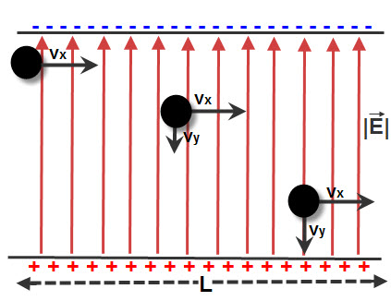
10. Use the diagram to answer the next question.

a) The time required for the particle to travel across the plates is 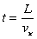. Show that the final vertical speed of the particle when it leaves the plates is 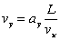. (1 mark)

b) Using Newton’s second law, show that the vertical acceleration is 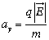. (1 mark)

c) Using the diagram above, draw a simple vector diagram and write out the tangent ratio for the diagram in terms of the angle, θ. (1 mark)

d) Recall that the horizontal speed of the cathode ray particles has already been determined (#9) and the values of L and are also known. The vertical speed and acceleration, however, are not known; therefore, we need to eliminate both when combining the equations. Show that the equations in the previous three questions can be combined to give the following expression: 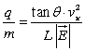. (1 mark)

e) Assuming values for θ, $v_{x}$, L and $\overset{⃑}{E}$ from the applet, calculate the q/m ratio of the cathode ray particles. (1 mark)

f) Using the accepted values of q and m from the data sheet, find the percent error in the calculation. The formula for percent error is listed on page 7 of this lab manual. (1 mark)

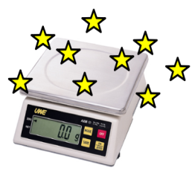
P30 Unit B: Determining the Magnetic Field Strength
Name: _________

Date: _________

Problem: Using the relationship between the current in a conducting wire and an outside uniform magnetic field, what is the magnitude of the external uniform magnetic field, in teslas?
/17
Hypothesis: (1 mark)

………………………………………………………………………………………………………
………………………………………………………………………………………………………

Design: A conducting wire of known mass, m, and length, L, is placed on an electronic weigh scale. A current, I, is produced in the wire. A uniform magnetic field, $\overset{⃑}{B}$, is placed near the wire. Using the relationship between the current and resulting apparent mass, the magnetic field of the magnetic is calculated.

Variables: (1 mark)

Controlled: ……………………………………………………………………………

Manipulated: ……………………………………………………………………………

Responding: ……………………………………………………………………………

Materials:

- Length of conducting wire
- Magnet (stronger the better)
- Electronic weigh scale
- Ammeter
- Variable voltage source
- Alligator clips
- Lab stand and clamp

Procedure:
1. Obtain a length of wire. Record the length of the wire, L, on the data table provided. Fold the wire to allow it to fix neatly on top of the weigh scale, if necessary.
2. Place the wire on the scale and attach a power supply via alligator clips. Record the starting mass.
3. Place the magnet in the clamp on the stand. Move the magnet near the wire.
4. Begin to increase the current flowing through the wire. Note the effect on the apparent mass of the wire. It is desirable for the mass to decrease.
5. Collect values of I and m and record on the data table provided. Be careful at higher currents! The power supply will switch off when the internal circuit is overloaded. It is best to turn up the current only momentarily to take a reading, then to decrease it again.

Data Table: (2 marks) Length of wire, L = ________ m
Current, I (mA) | Apparent Mass, m (g)

Graph: Create a graph of m vs. I. Extrapolate the graph to find the x-intercept. (2 marks)

Analysis:
State the x-intercept of the graph. (1 mark)

Draw a free body diagram of the forces acting on the wire. (1 mark)

Determine the magnetic field of the magnet. (2 marks)

Evaluation: When the current was increased, did the mass increase or decrease? Why? What did the x-intercept of the graph represent? How was the magnetic field strength calculated? What were the sources of error in the experiment? What improvements could be made to the lab to obtain better results? What is one method to check the validity of the determined magnetic field value? (7 marks)
………………………………………………………………………………………………………
………………………………………………………………………………………………………
………………………………………………………………………………………………………
………………………………………………………………………………………………………
………………………………………………………………………………………………………
………………………………………………………………………………………………………
………………………………………………………………………………………………………
………………………………………………………………………………………………………
………………………………………………………………………………………………………
………………………………………………………………………………………………………
………………………………………………………………………………………………………
………………………………………………………………………………………………………
………………………………………………………………………………………………………
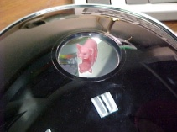
P30 Unit C: The Optics of Concave and Convex Mirrors
Name: _________

Date: _________
/8
Purpose: To determine the focal length of a concave and convex mirror and to observe three principle reflected lines needed for making ray diagrams.
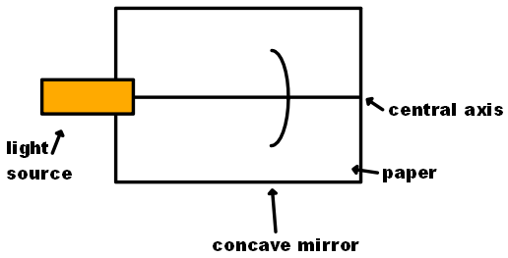
Design: A light source is pointed at a concave mirror. The focal length is measured, and the three principle reflected lines are observed and drawn out on a piece of paper underneath of the apparatus.

Materials:
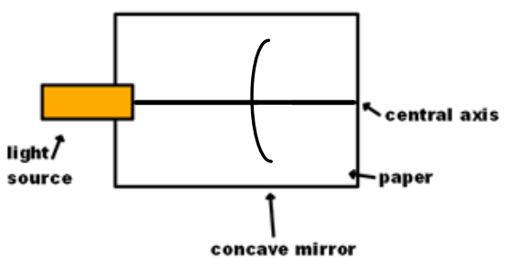
- Sheet of standard blank paper
- Light source with single slit attachment
- Concave (converging) mirror
- Ruler

Variables: (1 mark)

Controlled: ……………………………………………………………………………

Manipulated: ……………………………………………………………………………

Responding: ……………………………………………………………………………

Procedure: (Concave)

1. Using a ruler, draw a line to divide the paper into two halves (as in the design above). This line is the principle axis.

2. Place the light source at one end of the principle axis. Place the concave mirror about two-thirds of the way down the paper on the principle axis. Draw a mark where the mirror has been placed. Turn on the light.

3. Observe where the reflected light is converging in front of the mirror. This is the focal point. Mark the focal point along the principle axis (it may be necessary to tip the mirror slightly to see where the reflected light is focusing at the focal point). Mark the focal point and label it with a F.

4. Measure the distance from the focal point to the mirror. Double the distance and place a mark this distance in front of the mirror. This is the centre of curvature. Label the centre of curvature with a C.

5. Move the light source so the incident light ray is parallel to the principle axis. Observe and record the direction of the reflected light ray.

6. Move the light source so the incident light ray is passing through the focal point before hitting the mirror. Observe and record the direction of the reflected light ray.

7. Move the light source so the incident light ray is passing through the centre of curvature before hitting the mirror. Observe and record the direction of the reflected light ray.
Observations: (2 marks)

Focal Length of Concave Mirror = ________

Incident light passing parallel to the principle axis is reflected ___________________________.

Incident light passing through the focal point is reflected _______________________________.

Incident light passing through the centre of curvature is reflected _________________________.

Analysis: (2 marks)

Make a ray diagram of your observations in the space below. Include the focal point and centre of curvature. Assume the diagram is a view from above.

Procedure: (Convex)

1. Using a ruler, draw a line to divide the paper into two halves (as in the design above). This line is the principle axis.

2. Place the light source at one end of the principle axis. Place the convex mirror about two-thirds of the way down the paper on the principle axis. Draw a mark where the mirror has been placed. Turn on the light.
3. Move the light source so the incident light ray is parallel to the principle axis. Observe and record the direction of the reflected light ray on the paper. Move the light source to the other side of the principle axis and shine another ray parallel to the principle axis. Observe and record the direction of this reflected light ray on the paper.

4. Remove the mirror and extend the two reflected lines drawn in step 3. The point where these lines meet is the focal point. Mark the focal point and label it with a F.

5. Measure the distance from the focal point to the mirror. Double the distance and place a mark this distance in front of the mirror. This is the centre of curvature. Label the centre of curvature with a C.

6. Replace the mirror as before in step 3 and aim the light so that if the mirror were not there the ray would hit F. Observe and record the direction of the reflected light ray on the paper.

7. Move the light source and aim the light so that if the mirror were not there the ray would travel through C. Observe and record the direction of the reflected light ray.

Observations: (2 marks)

Focal Length of Concave Mirror = ________

Incident light passing parallel to the principle axis is reflected ___________________________.

Incident light passing through the focal point is reflected _______________________________.

Incident light passing through the centre of curvature is reflected _________________________.

Analysis: (2 marks)

Make a ray diagram of your observations in the space below. Include the focal point and centre of curvature. Assume the diagram is a view from above.

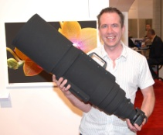
P30 Unit C: The Optics of Convex Thin Lenses
Name: _________

Date: _________
/16
Purpose: To determine the focal length of a convex lens.

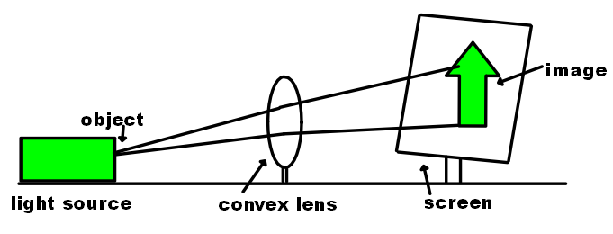
Design: A light source in the shape of an arrow is pointed at a convex lens. The lens reduces/enlarges/inverts the image of the arrow onto a screen behind the lens. The focal length of the lens is determined using a graph, as well as the characteristics (enlarged, diminished, inverted, erect) of the image.

Materials:

- Optical Bench (or Air Track)
- Light source with arrow cutout attachment
- convex (diverging) lens
- Ruler
- Screen
- Air-track attachment brackets
- Tape, sticky-tack, modeling clay

Variables: (1 mark)

Controlled: ……………………………………………………………………………

Manipulated: ……………………………………………………………………………

Responding: ……………………………………………………………………………

Procedure

1. Using tape, fix the light source onto one of the air-track attachment brackets. Slide the arrow shaped cut-out into the front of the light source. Place the light source on the air-track. This acts as the object in the lab.

2. Using a small amount of tape or clay, fix the lens onto another air-track bracket. Place the lens on the track. Fix the screen onto the track in a similar manor (there should be special brackets with a binder clip attached to fix the screen). The screen is where the image will appear.

3. Slide the screen to a distance of 30 cm from the light source.

4. Turn on the light and adjust the position of the lens until the arrow is clearly visible on the screen. Record the distance from the object to the lens (d_{o}) and the distance from the image to the lens (d_{i}) on the data table provided. Note the characteristics of the image (enlarged/diminished, erect/inverted) and record on the data table. Measure the height of the object (h_{o}) and the height of the image (h_{i}).

5. Slide the screen to a distance of 40 cm from the light source and repeat step 4.

6. Slide the screen to a distance of 50 cm from the light source and repeat step 5.

Observations: (3 marks)

 | Trial 1 (30 cm) | Trial 2 (40 cm) | Trial 3 (50 cm)
d_{o}
d_{i}
characteristics
h_{o}
h_{i}

Graph: Create a graph of $d_{i}^{-1}$ vs $d_{o}^{-1}$ below. Include a line of best fit. (2 marks)

Analysis:

Determination of the focal length using the y-int of the graph. (2 marks)

Determination of the magnification factor of the lens using the slope of the graph. (2 mark)

Evaluation: Explain how the focal length and magnification factor of the lens was determined. Summarize the trend in observations at different values of distance. Give one improvement to the lab and one source of error. (6 marks)
………………………………………………………………………………………………………
………………………………………………………………………………………………………
………………………………………………………………………………………………………
………………………………………………………………………………………………………
………………………………………………………………………………………………………
………………………………………………………………………………………………………
………………………………………………………………………………………………………
………………………………………………………………………………………………………
………………………………………………………………………………………………………
………………………………………………………………………………………………………
………………………………………………………………………………………………………

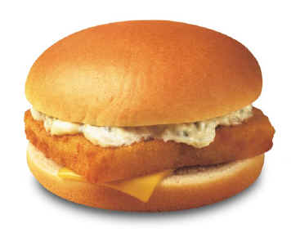
P30 Unit C: The Wave Nature of Light
Name: _____________

Date: _____________
/9
Activity 1: Poisson’s Bright Spot

Purpose: To observed evidence of the wave nature of light.

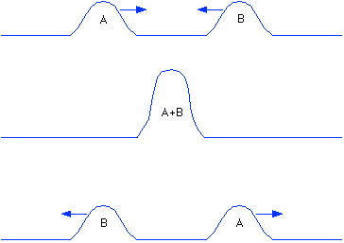
Background: Recall from Physics 20 Huygen’s Principle of waves: any wave can be thought of as a number of smaller “wavelets” that can be broken apart. When a wave encounters a solid barrier, some of these wavelets bend, or diffract, around the object. Then the diffracted waves collide, peak to peak or trough to trough, the constructively interfere.
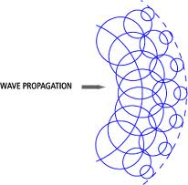
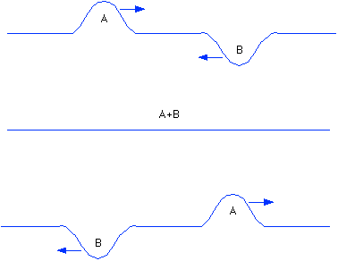

Two wave peaks undergo constructive interference.
A peak and a trough undergo destructive interference.
A large wave (semicircle) is made up of many small “wavelets” (small circles)

In 1818, Simone Poisson, a French physicist who believed light was a particle, stated that if light were truly a wave, when light rays encountered a circular barrier, they would bend around it, constructively interfering and producing a bright spot behind the barrier. Poisson did not believe this effect would occur.

Procedure:
1. Assemble the optics bench as shown in the diagram below. Use the circular disk mounted on the movable track and the circular light source attachment.

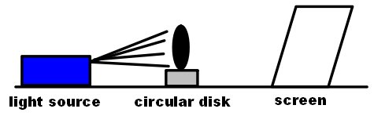
2. Adjust the distance between the light source and circular disk and observe the effects of the shadow being formed on the screen. Record the findings below.

Observations: Create a diagram of the shadow on formed in the experiment in the box below.(1 mark)

Activity 2: Scattered light from a triangular prism/diffraction grating.

Purpose: to compare and contrast the visible spectrum produced from triangular prisms and diffraction gratings.

Background: (Prism) The speed of light in a vacuum (c = 3.00 x 10⁸ m/s) is a well known value. But this only an upper limit to speed at which light can travel. When light travels through other mediums, it can change speed. This speed change causes the light to travel at a different angle upon entering the second medium, a principle called refraction.

When white light (a combination of violet, blue, green, yellow, orange and red light) is incident on a prism, the light refracts, causing a rainbow dispersion pattern. As refraction is dependent on wavelength, different wavelengths (colours) of light will disperse at different angles, separating the light into a spectrum.

Background: (Diffraction Grating) When light travels through small openings such as the tiny slits cut into glass as in a diffraction grating, the light constructively and destructively interferes to produce an interference pattern of bright spots and dark spots. This was studied in Young’s Double Slit Experiment and was one of the key arguments in proving light was a wave.
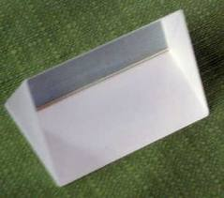
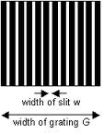

Procedure:

1. Place a light source on the lab bench. Obtain a triangular prism and shine the light through the prism. Obtain the diffraction grating and shine light through the grating.
2. Observe and record the results in the table below.

Observations:

Make a diagram of the spectrum of light going through the prism. What does the spectrum look like? (1 mark)

Which wavelength (colour) of light refracted the most in the prism? (1 mark)

Which wavelength (colour) of light refracted the least in the prism? (1 mark)

Make a diagram of the spectrum of light going through the diffraction grating. What does the spectrum look like? (1 mark)

Which wavelength (colour) of light refracted the most in the diffraction grating? (1 mark)

Which wavelength (colour) of light refracted the least in the diffraction grating? (1 mark)

Activity 3: Polarization

Purpose: to observe the effect of polarization on white light.
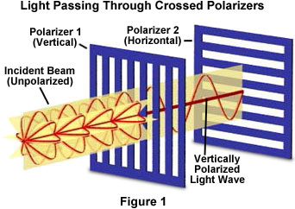
Background: Light is made up of perpendicular, self-propagating electric and magnetic fields. Typically, the waves of light are in a scattered orientation (unpolarized light). However, it is possible to screen some of the scattered waves out by passing the light through a polarizing material with openings that only allow wavelengths of a particular orientation (i.e. vertical or horizontal) to pass through. The resulting light only has waves in one dimension and is referred to as polarized light.

Activity:

Obtain two polarizing disks. Use the disks to observe light sources, your calculator screen, etc. Try placing the two disks one in front of the other and turn one of the disks. What is the result?

Explain your observations of light that passes through two polarizing disks. Use a diagram in your explanation. (2 marks)

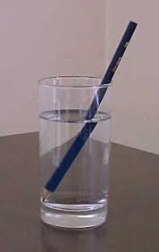
P30 Unit C: Determining the Index of Refraction Lab
Name: _____________

Date: _____________
(Adapted from Pearson Physics, page 667)
/18
Question: What are the indexes of refraction of water, methanol and Lucite?
Hypothesis: (Note: a list of n-values is given on page 667 of the Pearson textbook.) (1 mark)
………………………………………………………………………………………………………
………………………………………………………………………………………………………
………………………………………………………………………………………………………
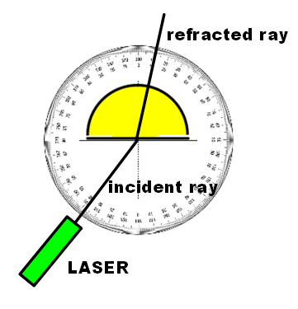
Design: Monochromatic light from a LASER is incident upon a semi-circular dish containing the material to be investigated. The angles of incidence, $θ_{i}$, and angles of refraction, $θ_{r}$, are measured using a double-protractor. A graph is used to determine the index of refraction of the material.
Materials:
- Semi-circular dish
- Water, methanol, Lucite block
- LASER pointer
Variables: (1 mark)

Controlled: ……………………………………………………………………………

Manipulated: ……………………………………………………………………………

Responding: ……………………………………………………………………………

Procedure:
1. Tear out the double-protractor page from the back of this lab manual. Place the semi-circular dish on top of the paper, with the flat edge lining up with the solid line on the protractor. Fill the dish with one of the materials listed.
2. Shine the LASER at the flat edge of the dish, starting at an angle of 0° to the normal. The angle of refraction should be 0°. If not, check the alignment of the dish and paper.
3. Set different angles of incidence and measure the coincident angles of refraction. Record the angles on the data table provided.
4. Repeat steps 2 and 3 with different mediums.

Data Table: (3 marks)

angle of incidence (θ_{i}) | angle of refraction (θ_{r}) | sin(θ_{i}) | sin(θ_{r})
0°
10°
20°
30°
40°
50°
60°
70°

Graph: Create a graph of $\sin{θ_{i}}$ vs $\sin{θ_{r}}$ for one of your mediums. Include a line of best fit. (3 marks)


*Alternate Method to Graphing: Create a graph of $\sin{θ_{i}}$ vs $\sin{θ_{r}}$ using your graphing calculator or a spreadsheet (see instructions at the back of this lab manual). (3 marks)

Analysis:
Sample calculation for index of refraction. (2 marks)

Sample percent error calculation. (2 marks)

Evaluation: Explain how the index of refraction for each material was calculated. State the index of refraction of each material. State the percent error of each index of refraction calculated. Explain why it is necessary to use a semi-circular dish instead of a rectangular dish in the lab. State one source of error and one improvement to the lab. (6 marks)
………………………………………………………………………………………………………
………………………………………………………………………………………………………
………………………………………………………………………………………………………
………………………………………………………………………………………………………
………………………………………………………………………………………………………
………………………………………………………………………………………………………
………………………………………………………………………………………………………
………………………………………………………………………………………………………
………………………………………………………………………………………………………
………………………………………………………………………………………………………
………………………………………………………………………………………………………
………………………………………………………………………………………………………
………………………………………………………………………………………………………
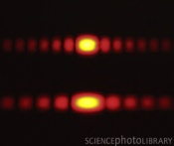
P30 Unit C: Investigation: Diffraction
Name: _____________

Date: _____________
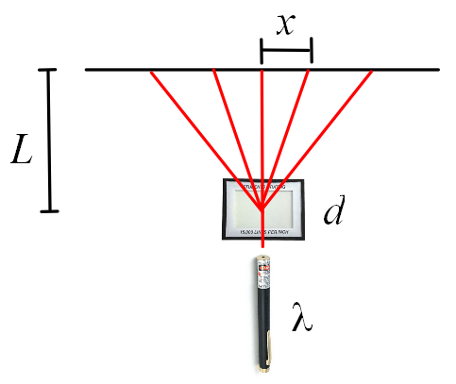
Purpose: To establish the effect of changing wavelength, slit separation and screen distance has on the interference pattern of EMR passing through a diffraction grating.
/12
Design: LASER light (or another light source) of wavelength λ is passed through a diffraction grating of slit separation d. The resulting interference pattern is observed. Changes to wavelength, slit separation and screen distance are then made to see the resulting changes in the interference pattern.
Materials:
- Diffraction gratings (at least two different spacing options)
- Variable wavelength light source (either different coloured light filters or LASERs of different colour)
Variables: (1 mark)

Controlled: ……………………………………………………………………………

Manipulated: ……………………………………………………………………………

Responding: ……………………………………………………………………………

Procedure: (For help writing a good procedure, see page 6 of this manual). (4 marks)
………………………………………………………………………………………………………
………………………………………………………………………………………………………
………………………………………………………………………………………………………
………………………………………………………………………………………………………
………………………………………………………………………………………………………
………………………………………………………………………………………………………
………………………………………………………………………………………………………
………………………………………………………………………………………………………
………………………………………………………………………………………………………
………………………………………………………………………………………………………
Observations: (4 marks)
Change Diagram

Controlled Test:

Increasing λ:

Increasing d:

Increasing L:

Summary: (3 marks)
State the relationship between x and each of the following variables:
L ……………………………………………………………………….
d ……………………………………………………………………….
λ ……………………………………………………………………….


P30 Unit C: Determining the Wavelength of EMR
Name: _____________

Date: _____________
(Adapted from Pearson Physics, page 694)
/16
Question: What is the wavelength of red, green and blue light?

Hypothesis: (1 mark)
………………………………………………………………………………………………………
………………………………………………………………………………………………………
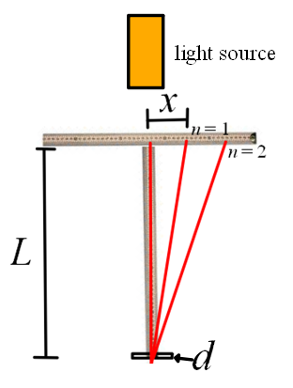
Design: A light source is incident on a diffraction grating of slit separation d. The distance to the screen, L, and the distance from the central antinode to each resulting antinode, x, is measured. From this, the wavelength of light is determined.

Materials:
- Two metre sticks
- Diffraction grating
- Light source

Variables: (1 mark)

Controlled: ……………………………………………………………………………

Manipulated: ……………………………………………………………………………

Responding: ……………………………………………………………………………

Procedure: (3 marks)
………………………………………………………………………………………………………
………………………………………………………………………………………………………
………………………………………………………………………………………………………
………………………………………………………………………………………………………
………………………………………………………………………………………………………
………………………………………………………………………………………………………
………………………………………………………………………………………………………
………………………………………………………………………………………………………
Data Table: (2 marks)

Analysis:

Sample Wavelength Calculation (state all wavelengths calculated) (3 marks)

1st antinode 2nd antinode Average

$λ_{red}$ = _________ $λ_{red}$ = _________ $λ_{red}$ = _________
$λ_{green}$ = _________ $λ_{green}$ = _________ $λ_{green}$ = _________
$λ_{blue}$ = _________ $λ_{blue}$ = _________ $λ_{blue}$ = _________

Evaluation: State the percent error of each wavelength of light, explain why each antinode appears as a rainbow, state how many antinodes should have been observed (assuming largest angle of diffraction to be 89°), state one source of error and one improvement to the lab. (6 marks)
………………………………………………………………………………………………………
………………………………………………………………………………………………………
………………………………………………………………………………………………………
………………………………………………………………………………………………………
………………………………………………………………………………………………………
………………………………………………………………………………………………………
………………………………………………………………………………………………………
………………………………………………………………………………………………………
………………………………………………………………………………………………………
………………………………………………………………………………………………………
………………………………………………………………………………………………………
………………………………………………………………………………………………………
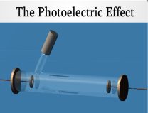
P30 Unit C – The
Name: _______

Date: _______
Photoelectric Effect Lab

Purpose: To determine the experimental value of h by measuring the work function W_{o} of a metal and threshold frequencies f_{o} of several wavelengths of light.
/21

Note: the applet can be found at http://kcvs.ca/details.html?key=photoelectricEffect

Hypothesis: (1 mark):
………………………………………………………………………………………………………
………………………………………………………………………………………………………
Experimental Design: (Explain what will be done in the lab to achieve the purpose. About 2-3 sentences long. Draw a diagram of the apparatus.) (2 marks)
……………………………………………………………………………………………………………………………….…..
……………………………………………………………………………………………………………………………………
……………………………………………………………………………………………………………………………………
…………………………………………………………………

Variables: (1 mark)

Controlled: ……………………………………………………………………………

Manipulated: ……………………………………………………………………………

Responding: ……………………………………………………………………………

Procedure:

1. Access the Photoelectric Effect applet. Take a few minutes to play around with the settings.

2. Choose a metal cathode from the options menu.

3. Move the wavelength/frequency slider all the way to the right to produce low frequency/high wavelength photons. Gradually increase the frequency by moving the slider left. Stop when the first photoelectron is emitted.

4. Increase the voltage until the photoelectrons no longer hit the far negative plate. Hit the “Record Data” button or record the wavelength, frequency and stopping voltage on the data table provided.

5. Increase the frequency by a small amount until the photoelectrons hit the far plate again and a current is observed in the ammeter. Once the current is observed, increase the stopping voltage as in step 4. Record the data point.

6. Continue collecting data for at least 6 points.

Data Table: (Include appropriate units) (3 marks)

Wavelength of light (nm) and Colour of Light | Threshold Frequency  (10¹⁵ Hz) | Stopping Voltage  (V)

Graph: Construct a graph of Work Function, W vs. Threshold Frequency, f_{o}. Include a line of best fit. (2 marks)

Analysis:

Slope Calculation of W vs. f_{o} graph. (2 marks)

Interpretation of Slope Calculation. (2 marks)

Interpretation of x-intercept. (2 marks)

Interpretation of y-intercept. (2 marks)

Calculation of h. (2 marks)

Evaluation: Just list sources of error and a percent error calculation. (2 marks)

………………………………………………………………………………………………………
………………………………………………………………………………………………………
………………………………………………………………………………………………………
………………………………………………………………………………………………………
………………………………………………………………………………………………………
………………………………………………………………………………………………………
………………………………………………………………………………………………………
………………………………………………………………………………………………………

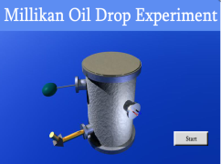
P30 Unit D: A Millikan-Like Oil-Drop Lab
/12
Name: _________

Date: _________
Note: the applet can be found at http://kcvs.ca/details.html?key=millikanExperiment

Question: What is the value of the elementary charge, q_{e}?
Hypothesis: (1 mark):
………………………………………………………………………………………………………
………………………………………………………………………………………………………
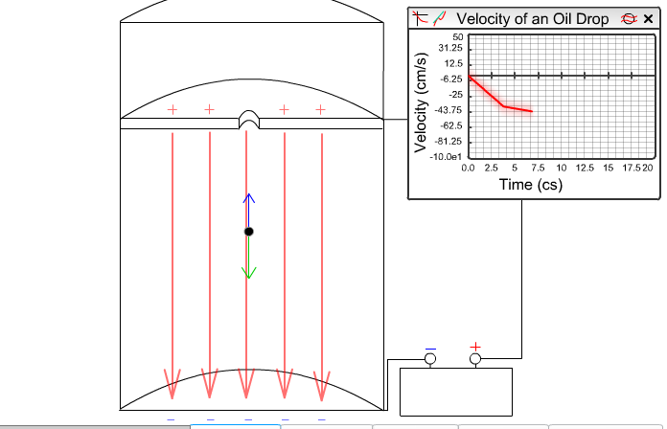
Design: This is a Millikan-like oil-drop lab because it will ignore the force of drag on the oil drop, greatly simplifying the lab. An electric field is applied to an oil drop of mass m with an unknown charge, q, causing it to move with uniform motion. An analysis of the forces allows the charge on the electron to be determined.
Variables: (1 mark)

Controlled: ……………………………………………………………………………

Manipulated: ……………………………………………………………………………

Responding: ……………………………………………………………………………
Procedure:
1. Access the Millikan Effect applet. Take a few minutes to play around with the settings.

2. Under the “Options” menu, turn on the “v-t graph”, “force” and “electric field” direction settings.

3. Click “Start” to send an oil drop through the apparatus.

4. Adjust the voltage between the plates until the oil drop moves with uniform motion. You can hit “Rewind” to allow for small adjustments to the voltage. At this point, click on the “Record Data” button.

5. Click “Reset” and repeat steps 2-4 for the new drop. This drop will have identical mass, but a different charge.

Data Table: (2 marks)

Mass of oil drop: ________ kg Plate Separation = ___________ mm

Trial | Voltage (kV) | Electric Field (kV/m)

Analysis:
Sample oil drop charge calculation. (3 marks)

Evaluation: Comment on how the oil drop’s charge was calculated, how the elementary charge could be determined from the charge on each oil drop, sources of error and one improvement to the lab. (5 marks)
………………………………………………………………………………………………………
………………………………………………………………………………………………………
………………………………………………………………………………………………………
………………………………………………………………………………………………………
………………………………………………………………………………………………………
………………………………………………………………………………………………………
………………………………………………………………………………………………………
………………………………………………………………………………………………………
………………………………………………………………………………………………………
………………………………………………………………………………………………………

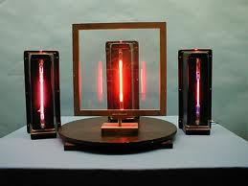
P30 Unit D: Emission Line Spectra Observation Sheet
Name: _________

Date: _________
Background: Niels Bohr won the Nobel Prize in Physics in 1922 for his work with studying the EMR created from excited gases. Bohr discovered that each element, in the gaseous form, emits different wavelengths of light when a high voltage current is passed through them. Bohr related this observation to the downward jump of electrons in the orbitals of an atom. This became known as the Bohr Model of the atom.
Observations:
Element Name and Colour | Spectrum Diagram

Extension: Compare these spectra to the element spectra found at http://astro.u-strasbg.fr/~koppen/discharge/discharge.html.

Sample Data

Sample Data for Conservation of 1D Momentum Lab

Data Table:

m₁ = _0.202 kg_ m₂ = _0.203 kg_ d₁ = _0.0300 m_ d₂ = _0.0300 m_

 | Before Collision |  |  | After Collision
Trial | t₁ | v₁ | p_{i} | t₂ | v₂ | p_{f}
1 | 0.235 | 0.128 | 0.0259 | 0.540 | 0.0556 | 0.0225
2 | 0.181 | 0.166 | 0.0335 | 0.450 | 0.0667 | 0.0270
3 | 0.211 | 0.142 | 0.0287 | 0.066 | 0.0644 | 0.0261
4 | 0.218 | 0.138 | 0.0279 | 0.501 | 0.599 | 0.0243

Sample Data for Air Table Lab

Evidence:
Average mass of a puck = 567.7 g
Spark timer setting = 50 ms.

Data Table:
Before Collision |  |  |  |  | After Collision
 | A | B | total |  | A | B | total
v_{r} | -0.48 | 0.26 | n/a |  | 0.24 | 0.31 | n/a
p_{r} | -0.27 | 0.15 | n/a |  | 0.14 | 0.18 | n/a
p_{x} | -0.27 | 0.15 | -0.12 |  | -0.13 | -0.17 | -0.041
p_{y} | 0 | 0 | 0 |  | -0.035 | -0.034 | -0.0017
*velocities are in m/s and momentums are in kgm/s.

Online Animation for Nature of Charge and the Electroscope
You can use these animations to simulate the experiment if you missed doing it for real:
http://www.physicsclassroom.com/mmedia/estatics/epn.cfm

Coulomb’s Law (Version 1)

Coulomb’s Law (Version 2)

Lenz’s Law Lab:
You can use this applet to simulate the experiment if you missed doing it for real:
https://nationalmaglab.org/education/magnet-academy/watch-play/interactive/electromagnetic-induction
Sample Data for Determining Magnetic Field Strength Lab
Data Table:
Length of wire, L = 0.78 m
Current, I (mA) | Apparent Mass, m (g)
0 | 25.3
.2 | 25.2
.3 | 25.0
.4 | 24.8
.5 | 24.5
.6 | 24.0
.7 | 23.8

The Optics of Convex and Concave Mirrors
If you missed this lab, here are some good applets that go through the ideas:
https://elearning.cpp.edu/learning-objects/objects.php?page=1&keyword=physics
https://www.olympus-lifescience.com/en/microscope-resource/primer/lightandcolor/java/

The Optics of Convex Thin Lenses

 | Trial 1 (30 cm) | Trial 2 (40 cm) | Trial 3 (50 cm)
d_{o} (m) | 0.050 | 0.045 | 0.040
d_{i} (m) | 0.250 | 0.355 | 0.560
characteristics | enlarged, inverted | enlarged, inverted | enlarged, inverted
h_{o} (m) | 0.0125 | 0.0125 | 0.0125
h_{i} (m) | 0.070 | 0.090 | 0.095

The Wave Nature of Light
For Poisson’s Bright Spot: https://lecdem.physics.umd.edu/m/m2/m2-03.html
For prisms vs. diffraction gratings: http://buphy.bu.edu/~duffy/semester2/c26_prism_grating.html
For polarization:
https://www.olympus-lifescience.com/en/microscope-resource/primer/java/polarizedlight/3dpolarized/

Determining Index of Refraction Lab
(Water)

angle of incidence (θ_{i}) | angle of refraction (θ_{r}) | sin(θ_{i}) | sin(θ_{r})
0° | 0 | 0 | 0
10° | 7 | 0.173648 | 0.121869
20° | 16 | 0.34202 | 0.275637
30° | 24 | 0.5 | 0.406737
40° | 27.5 | 0.642788 | 0.461749
50° | 33.5 | 0.766044 | 0.551937
60° | 39.5 | 0.866025 | 0.636078
70° | 46 | 0.939693 | 0.71934

Investigation: Diffraction
You can use this applet to simulate the experiment if you missed doing it for real:
https://www.olympus-lifescience.com/en/microscope-resource/primer/java/diffraction/

Determining the Wavelength of EMR
d: 300 lines / 1 mm 0.001 m /300 lines 3.33 x 10⁻⁶ m
L = 1 m
1st antinode: x_{red} = 72.5 cm, x_{green} = 68.5 cm, x_{blue} = 65.5 cm
2st antinode: x_{red} = 94.0 cm, x_{green} = 84.0 cm, x_{blue} = 80.5 cm

Emission Line Spectra Observation Sheet:
If you missed the experiment, you can use this animation to help you:
https://www.khanacademy.org/partner-content/nasa/measuringuniverse/spectroscopy/a/absorptionemission-lines

Performing a Linear Regression on the TI-84 Plus Calculator

This method will allow you to quickly take data points that form a line when graphed and calculate their slope. In physics, this can be very helpful when finding velocities or accelerations from graphs of distance vs. time or velocity vs. time.

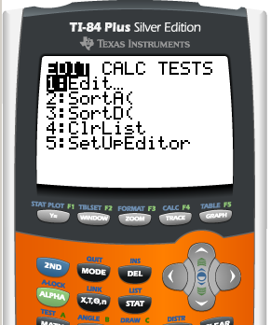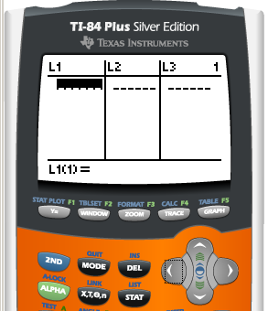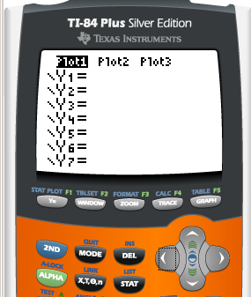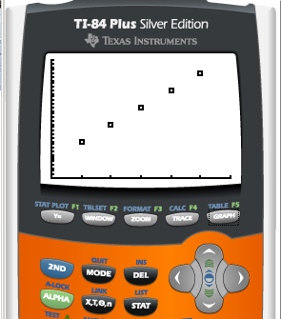
4. Use the WINDOW functions as needed to see your graph. The dots should form a rough line.
3. You can now view your graph. Press Y=, clear out any old equations you might have entered in, then scroll up to Plot 1 and press ENTER until it turns black.
2. This is the list menu. Enter the values of x in L₁ and y in L₂. To clear out a large number of old data points, scroll up to the L₁ or L₂ title, press CLEAR then ENTER.
1. From the main screen, press STAT, then press ENTER on Edit…

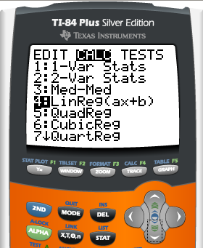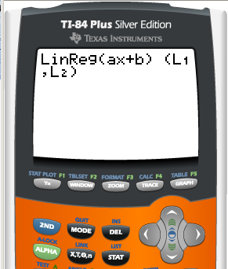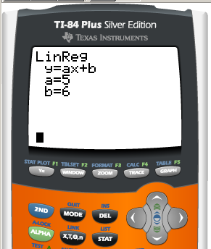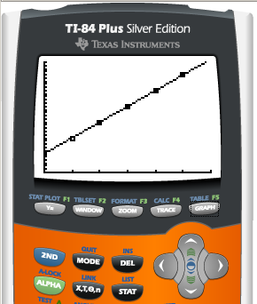
8. …or while in the Y= screen by pressing VARS, scrolling down to Statistics…, pressing ENTER then scrolling right to EQ and hitting ENTER on RegEq. If all went well, the plotted points should match the line.
7. This is your regression equation. The value of “a” is the slope, the value of “b” is the y-intercept.

To see how this equation matches your data, enter it into the Y= menu by hand…
6. If you have no other data entered into your calculator, you can just press ENTER. If you have other data in the Stat Plot menu, enter in (L₁, L₂) behind the LinReg(ax+b) command, then press ENTER.
5. Press STAT, then scroll one right to CALC, scroll down and press ENTER on LinReg (ax+b). This is the Linear Regression feature.
Creating Graphs Easily in Microsoft Excel

Excel is a powerful graph creating program, creating graphs more accurate than one could create on paper and with less time. It can even do regressions similar to the TI-83 calculator to determine slopes of linear sets of data.

To create a linear graph in Excel (2007 version, although previous versions work in a similar manner):

1. Open a new document.
2. Enter the data to be graphed horizontally as shown below. The y-axis values appear above the x-axis values.

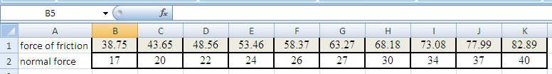

3. Highlight the cells with the data and click on “Insert” and “Chart”. Choose the scatter plot graph.
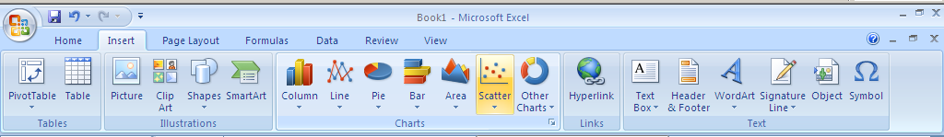

4. By right clicking on the axis, you can change the increments, gridlines shown and labels. You can also double-click the title to edit it if you wish.

5. To calculate slope: In the equation editor bar at the top of the screen, type in =SLOPE( , then in the brackets place the range of y-value cells (highlighting the cells you want works also) in the format FIRST CELL:LAST CELL. Notice in the example used here, the first y-value was in B1 and the last was in K1. Therefore, the y-value range was B1:K1.

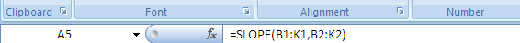

Using a comma to separate the y-value range, enter in the x-value range in the same way.

6. Press [ENTER] and the slope of the data will appear in the cell you originally clicked.

