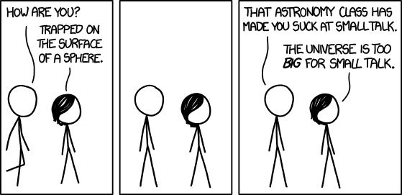
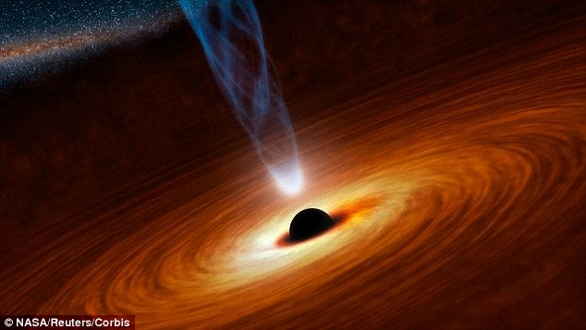

Unit 4
Stars & Galaxies

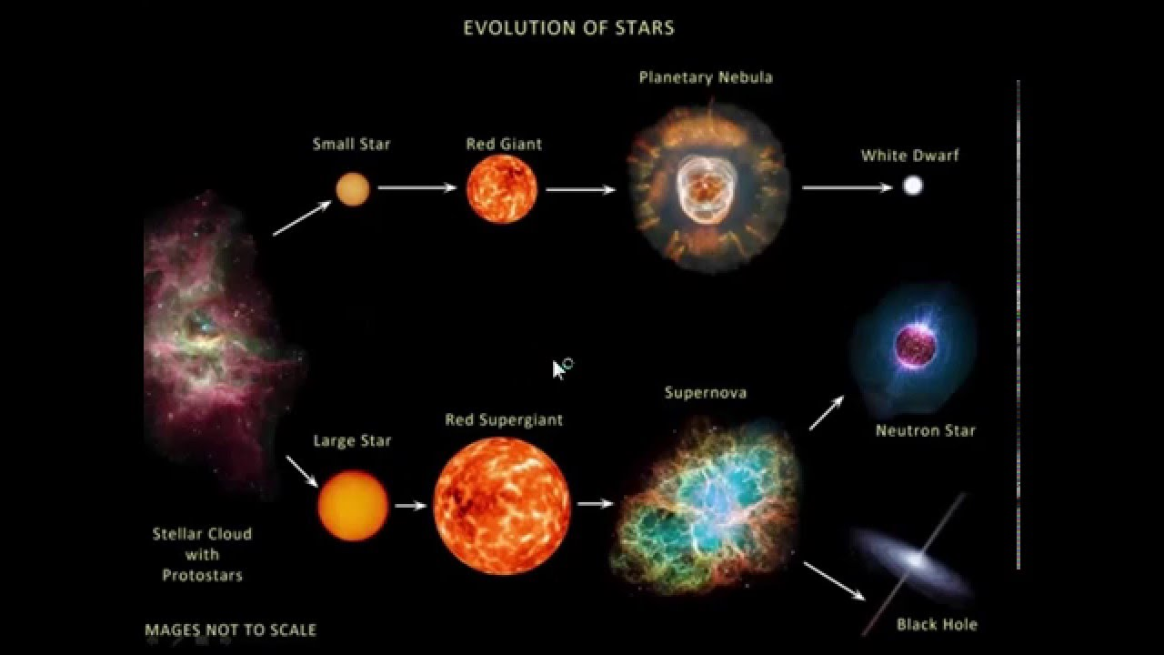

Lesson 1: Parallax
- What is an AU? What is a Parsec?

- Why did it take until the late 1800s to successfully measure the first parallax angle?

- Complete the table below:
Star | Parallax Angle | Distance
Epsilon Eridani | 0.310”
Procyon | 0.286”
Vega |  | 7.68 parsecs
Polaris |  | 434 light years
Deneb | 0.0029”
Barnard’s Star |  | 1.834 parsecs

- Draw and label a diagram showing how the motion of the Earth around the Sun is used to measure the parallax angle of a star.

Lesson 2: Fingerprints in Sunlight
- Newton was the first person to show that a beam of white light could be broken down into its component colours. Research and explain how he was able to do this.

- Explain the difference between absorption, emission and continuous spectrums.

- How will the absorption spectrum and the emission spectrum of Helium differ?

- The chart below shows the different regions of the Electromagnetic Spectrum (of which visible light is part of). Use the chart to determine which part of the spectrum each of the wavelengths of EMR belong to.
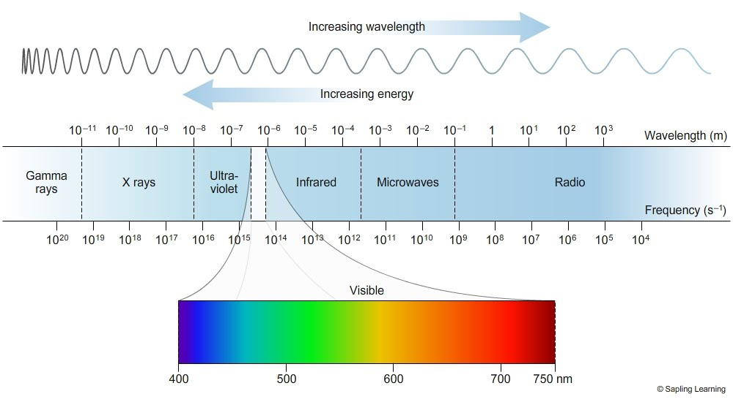
- 2.6 μm

- 34 m

- 0.14 nm

- 0.000055 nm

- 0.042 m

- Using the reference spectrums below, identify the gases present in the mystery star.
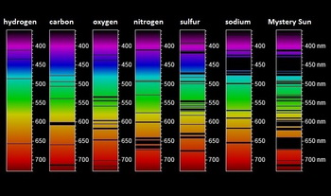

Lesson 3: Size of the Universe
The velocity of a galaxy can be determined by measuring the shift of its spectral lines.
The spectrum of Hydrogen is shown below.
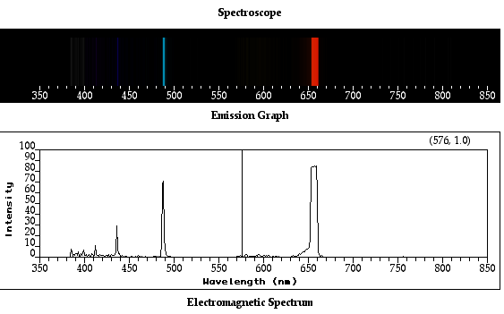

Several Galaxies with their spectra are shown below.

Galaxy A
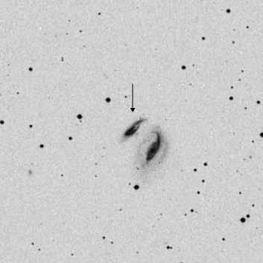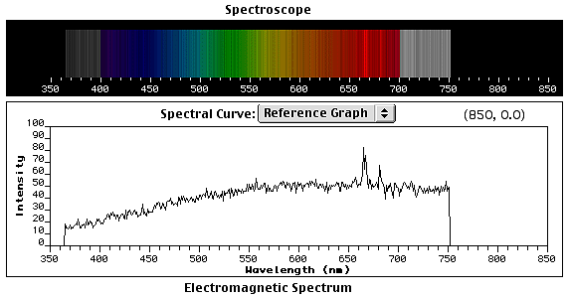

Galaxy B
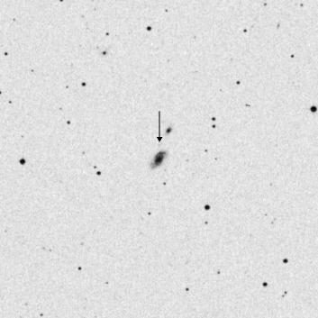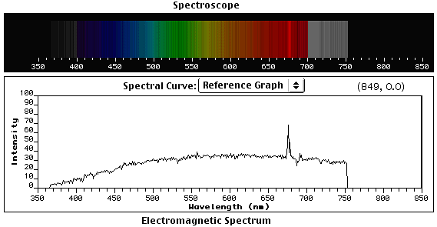

Galaxy C
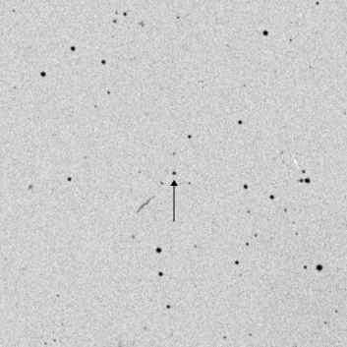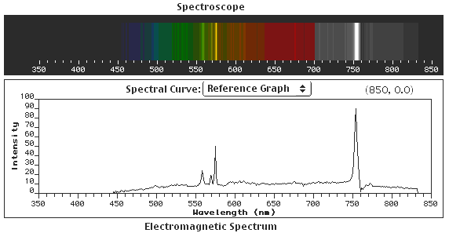

Galaxy D
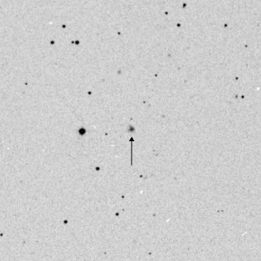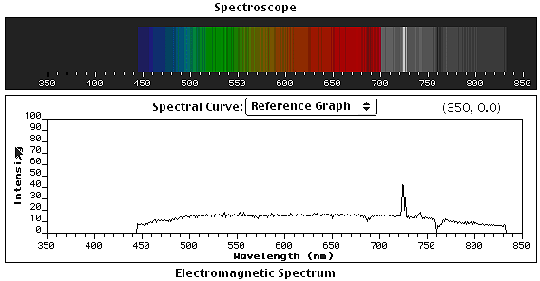

Galaxy E
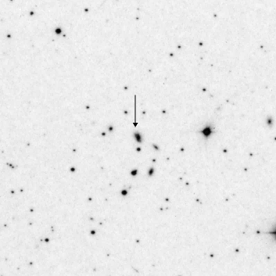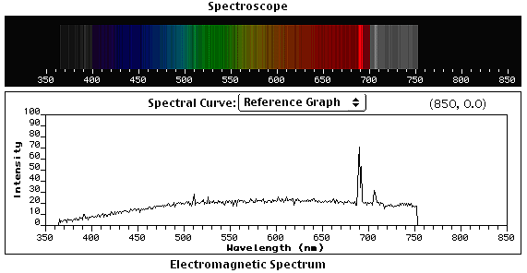

Use the Laboratory Hydrogen as a reference, answer the following questions.
- Based on the Red Shift, rank the galaxies in order of distance from Earth.

- What type of Feature (Absorption, Emission or Continuous) is the Red Line in the spectrum of each galaxy?

- The spectrum of each of the galaxies shows additional colours that are not present in the lab spectrum. What do you think these colours are?

BONUS
4. The equation can be used to determine the speed of a galaxy where:
λ = Lab wavelength measurement (nm)
Δλ = Amount wavelength has shifted (nm)
v = Recessional Velocity
c = 3.00 x 10⁵ km/s (speed of light)

Using this equation, determine the speed of each of the galaxies.

Lesson 4: Active Galaxies
- Summarize what causes active galactic nuclei.

- Why don’t we see any active galaxies near us?

- What is the Eddington Limit and what does it tell us about Active Galaxies?

- What is a Blazar?

Lesson 5: Dark Matter & Energy
- Explain the difference between Dark Matter and Dark Energy.

- Despite not being able to see Dark Matter, why do Astronomers believe it exists?

- Do you believe the universe will continue to accelerate? Why or why not?

Lesson 6: Stellar Evolution
Using the applets on the websites to help you:
https://phet.colorado.edu/sims/html/blackbody-spectrum/latest/blackbody-spectrum_en.html
http://www.kcvs.ca/details.html?key=starColour
http://www.kcvs.ca/details.html?key=spectralType
Complete the following activities.
- Spectrum
  - Identify the colour of light that corresponds to each of the following wavelengths:
    - 430 nm
    - 550 nm
    - 635 nm
    - 715 nm

- Star Colour
  - Identify the colour of the star that corresponds to each of the temperatures below
    - 3200 K
    - 5800 K
    - 7400 K
    - 11000 K
    - 25000 K

  - What happens to the wavelength of light emitted as the surface temperature of the star increases?

- Spectral Type
  - What is the wavelength of the most prominent lines for the types of stars below:
    - M
    - K
    - A
    - O

- Star Maker
  - Assume the slider at the bottom of the applet changes the mass of the star. What changes occur as the mass of the star increases?

  - How would increasing the mass of a star affect the rate of nuclear fusion?

  - What effect would the answer from question b. have on the colour of the star?

Lesson 7: The Cosmic Distance Ladder
- Complete the table below by identifying how astronomers determine the distance to celestial objects at different distances.

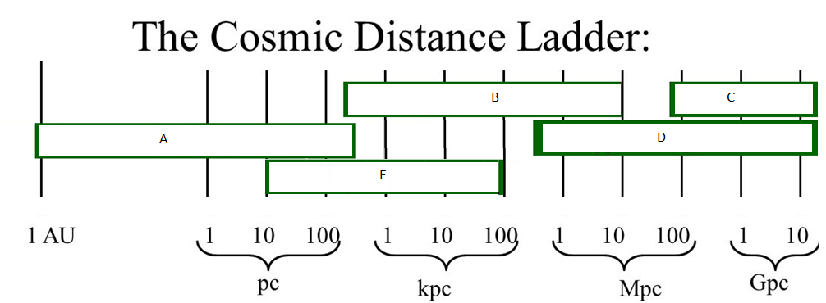

- ______________________________________________
- ______________________________________________
- ______________________________________________
- ______________________________________________
- ______________________________________________

- Explain why parallax measurements are only effective for stars up to 1000 light years in distance.

- Explain how the difference in absolute and intrinsic brightness is used to determine the distance to stars.

- Compare and contrast (give one similarity and one difference) in using type Ia Supernovas and Hubble’s law to determine distances.

Lesson 8: The Big Bang Theory
- Summarize the evidence for the Big Bang Theory.

- What is meant by an open universe? A closed universe? Does current evidence support an open or closed universe?

