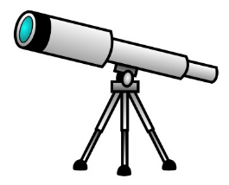
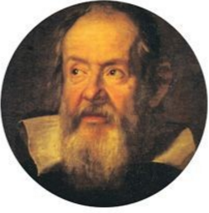

Unit 3
The Night Sky with Binoculars and Telescopes

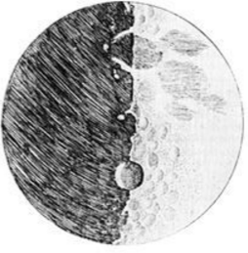

Lesson 1&2: Refracting vs. Reflecting Telescopes
- What are 2 benefits of reflecting telescopes vs refracting telescopes?

- What is one drawback of a refracting telescope?

- Why do you think the largest telescopes in the world are made of mirrors rather than lenses?

- Draw a diagram showing the light path in a Newtonian Reflecting telescope.

- What is the primary difference between a Schmidt Cassegrain and Newtonian telescope?

- Using the internet, read about the telescopes below. If you could buy one, which would it be and why?
  - Celestron 8” SCT
  - Skywatcher Esprit 120 mm
  - Obsession 20”
  - Meade ETX 125 mm

Lesson 3: Properties of Telescopes
- Use the information of the telescopes below to determine the magnification and number of times brighter than the naked eye objects will appear. (Use a pupil diameter of 4 mm for the human eye).
Telescope | Objective Focal Length | Eyepiece Focal Length | Radius | x Brighter than naked eye | Magnification
Hubble | 57.6 m | 40 mm | 1.2 m
James Webb | 131.4 m | 5 mm | 3.25 m
Keck | 17.5 m | 7 mm | 5.0 m
Thirty Meter Telescope | 450 m | 12 mm | 15 m

- Two telescopes are compared. The first telescope gathers 100 times as much light as the second telescope. If the second telescope has a primary mirror with a radius of 3” what is the diameter of the first telescope?

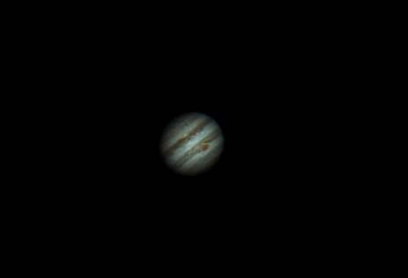
- The image of Jupiter shown below is magnified 375x. The eyepiece used has a focal length of 5 mm. Determine the focal length of the telescope.

- A telescope with an objective lens of focal length 550 mm is used to magnify a galaxy 150x. Determine the focal length of the eye piece that was used.

- High magnification is not always beneficial for astronomers. What are two reasons why an astronomer might not want an eye piece with a short focal length?

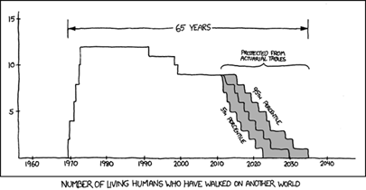
Lesson 4: The Formation of the Solar System
- Explain what is meant by the Nebular Hypothesis.

- Explain why the Terrestrial Planets form close to the sun while the Gas giants form farther away.

- Explain why Terrestrial planets are usually smaller while Gas Giants are typically larger.

- 98% of the mass of the solar system is made up of Hydrogen and Helium. Why aren’t the Earth and the moon composed primarily of Hydrogen and Helium?

- Give a reason why all the planets orbit the sun in the same direction.

- Estimates put the solar system’s age to be roughly 4.5 Billion years. Describe evidence that supports that age.

- Suggest a reason why Gas giants are orbited by Terrestrial-like moons.

Lesson 5: Nebulae and Variable Stars
- Compare and contrast the different types of Nebulas.

- Compare and contrast the different types of Variable Stars.

- Explain how a Nova is different than a Supernova.

- How are pulsating and eclipsing variable stars similar?

- What is the relationship between a Supernova and a Nebula?

- What equipment would you need to observe an eclipsing binary star?

Lesson 6: Exoplanets
- Describe 3 different methods used to search for exoplanets.

- Describe 3 different classes of exoplanets.

- What method of searching for exoplanets has had the most success?

- What is meant by the term ‘selection bias’ and what does it tell us about the types of exoplanets we’ve found?

- Describe the habitable zone around stars. What determines where this is?

- How many planets in our solar system are in or near the habitable zone?

- Using the website www.planethunters.org look for exoplanets.

Lesson 6: Interstellar Travel
Using the information found on https://breakthroughinitiatives.org/ answer the following questions.
- What is Breakthrough Starshot?

- What is Breakthrough Listen?

- Who is (or was)on the board of directors of the Breakthrough projects?

- What is a light beamer?

- What is special about nanocrafts? Why are they used rather than regular space craft?

- What type of instruments will the nanocraft carry?

- Why has the Breakthrough Starshot chosen Proxima Centauri as a destination?

- Do you believe the Project will succeed? Why or why not?

- What has a better chance of success; Project Listen or Project Starshot? Why?

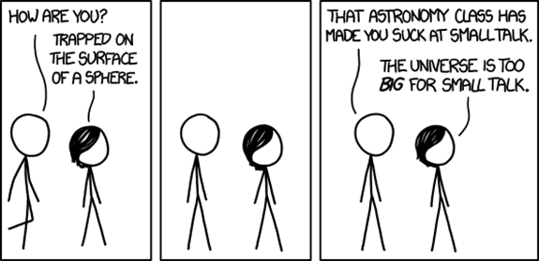
- Sketch a diagram of a space craft that uses one of the propulsion methods discussed in class. Where would you first travel to? How long do you think it would take to get there? What materials would you need to build your craft?

