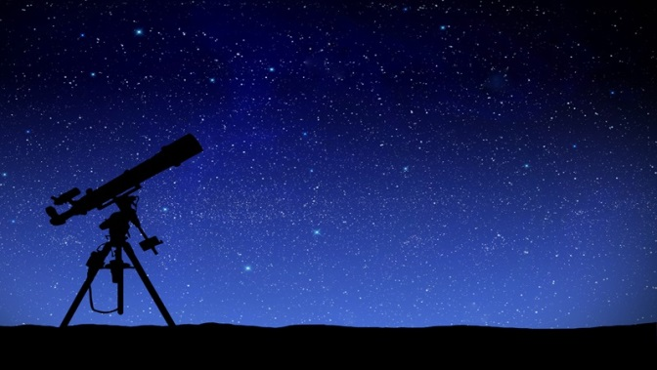
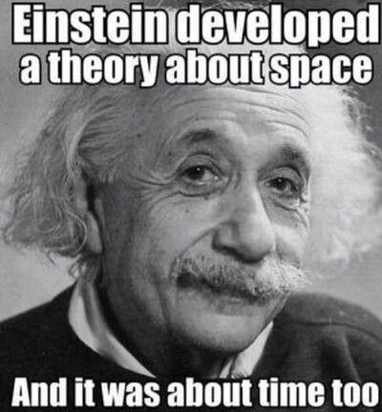

Astronomy 15
Unit 1: The Daytime Sky

Name: ______________________

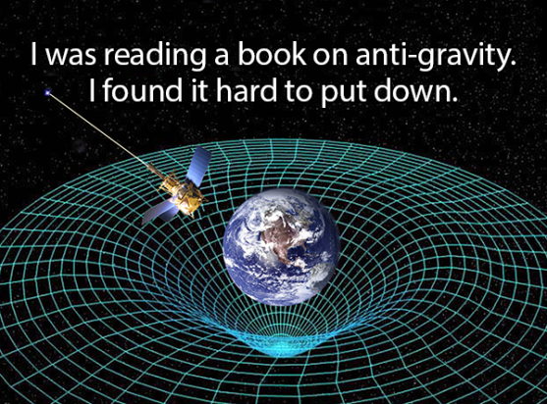
Lesson 1: Seeing, Transparency & Light Pollution
- Explain what is meant by seeing.

- What causes stars to twinkle? What time of night would you expect stars to twinkle the most?

- What is adaptive optics? How does it work?

- Why doesn’t the Hubble telescope need an adaptive optics suite?

- Using the star images below, rank the seeing when the star was visible.
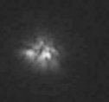

- What type of Electromagnetic Radiation is the sky mostly transparent to? What type of Electromagnetic Radiation is blocked by the atmosphere?

- How can we limit light pollution?

- What are some negative effects of light pollution?

Lesson 2: Telescope Basics
      - In your group, carefully set up your telescope. Is the telescope a reflecting or a refracting telescope?

      - Identify the Polar Axis and Declination Axis of the Telescope.

      - Look through the telescope at a nearby street light. What do you notice about the image through the telescope? If you move the telescope to the right, which way does the image through the telescope move?

Lesson 3: Observing the Sun
- What are some safety precautions you need to be aware of when viewing the sun? What are three ways the sun can be safely viewed?

- Explain how you set up the telescope and located the sun with it.

- Sketch a diagram of the sun as you saw it on your piece of paper.

- Explain the difference between a white light and hydrogen alpha filter for solar viewing.

- What part of the sun can be observed with a Hydrogen Alpha Filter?

Lesson 4: The Sun
- How much of the solar system’s mass is in the Sun? What makes up the rest of the solar system?

- Draw a diagram showing the relative sizes of the Sun, Earth, Moon, Jupiter and Saturn.

- What are Sun Spots? How does the temperature of a Sun Spot compare with the rest of the sun?

- What are the two different parts of Sun Spots?

- What causes sun spots?

- Compare and contrast the magnetic field of the Earth and the Sun. How are they similar? How are the different?

- Define a Solar Prominence and a Solar Flare.

- What is meant by Hydrostatic Equilibrium?

- How does the temperature of the Sun’s Core compare with its surface?

- What process provides the energy for the sun?

- What is the current age of the sun? How old to Physicists expect the total Sun’s life to be?

- What is the most likely end state for the Sun?

Lesson 5: How We Measure Time
- What is Apparent Solar Time? What is Mean Solar Time?

- What causes the difference between apparent and mean solar time?

- What is the Equation of Time?

- What is an Analemma?

- Where is the Equation of time used in our lives?

Constructing the Analemma
Steps:
- Open the program Stellarium
- Open the location window (move your cursor to the left hand side of the screen, its at the top) and set the Location to Edmonton.
- Set the date to today’s date at noon.
- Look at the handout you’re given. Note the elevation and azimuth markings on the page. Use those as references.
- Record the position of the sun using a pen.
- Advance the date by 10 days by pressing the equal key ‘=’ 10 times. Record the position of the sun again.
- Repeat step 6 36 times, until you traced the path of the sun over one complete year.
- Draw a smooth curve connecting the dots.

Questions:
- What is the shape of the Analemma?

- During what month is the sun highest in the sky?

- During what month is the sun lowest in the sky?

- What is the date when the sun reaches the top of the Analemma?

- When does the sun reach the lowest point of the Analemma?

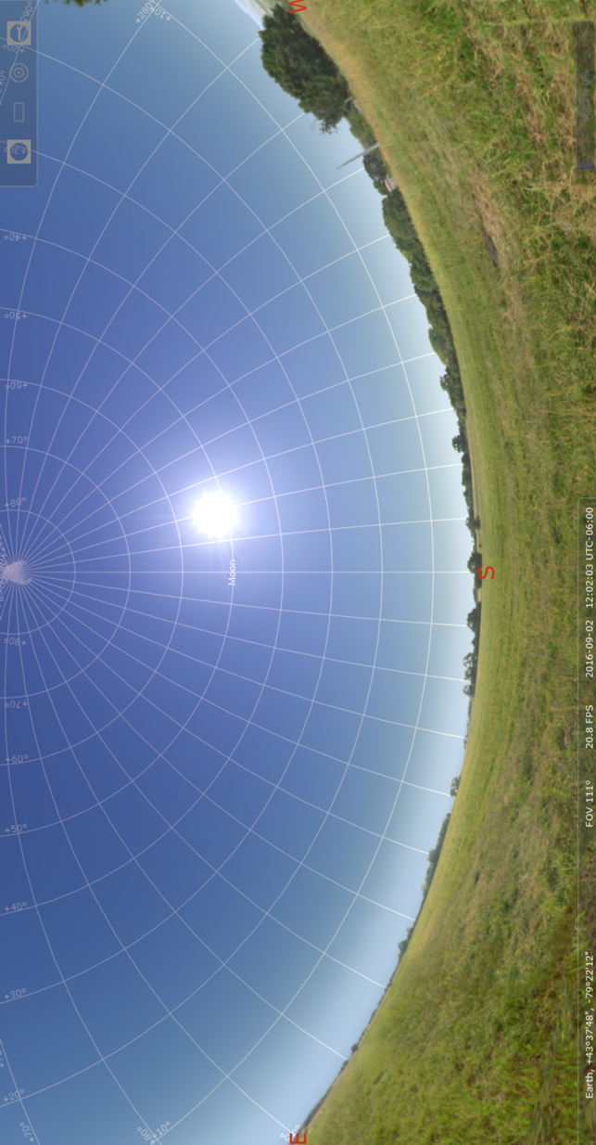

Lesson 7: The Motion of the Sky
- Draw a diagram of the Celestial Sphere. On your diagram, include the following labels:
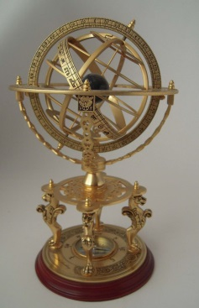
- North Celestial Pole
- South Celestial Pole
- Ecliptic
- Right Ascension
- Declination
- Vernal Equinox
- Summer Solstice
- Winter Solstice

- Define each of the terms in questions 1.

- What causes the Earth’s seasons?

- Draw a diagram showing how the rays of the sun strike the Earth’s surface in the summer and in the winter.

- A student makes the following statement:
The Earth’s orbit is not completely circular. It is squashed like an egg so the Earth is closer to the sun when during part of its orbit. Because the Earth is closer to the sun during this time, we experience summer.

Explain why this reasoning is not correct.

- Using the internet and determine when the winter solstice is. What is unique about this date?

